

Up的话

亲爱的同学，

词汇是英语学习的根本， 现在市面上的词汇课大概有两个类型。

一种是自下而上型(bottom-up)的：如四六级大纲词汇表，乱序词汇，红皮书，白皮书等。这些词汇课程有一些是利用谐音、构词法、词源等手段讲解词汇，总结词汇。

另一种是自上而下的方法：利用文章、音频等方式，通过学习者已有知识来拓展词汇，在学习词汇的同时还学习文章的意思。

两种流派各有优劣势。第一种适合考前突击，短期记忆效果好。第二种适合扎实打牢基础，真正看懂文章，提升英语水平。

**这套课程主要是利用第二种自上而下的方式（top-down）**。包含了2000左右四六级的常用词汇，穿插在35篇文章里，包含了英语考试中常见话题，如：语言文化、医疗健康、自然科学、互联网、国际组织、政治、经济、职场等话题词汇。**课程中也会讲解英语构词法、联想法、词根词缀、词源等方法。学完以后，你应该能看懂文章**。

关于这次版本的更新：新增了5篇文章、增加了部分文章的词汇英文解释、重新文章音频。

最后，祝大家学习愉快，希望大家能够跟着下半年学习计划（发布在B站指定动态）一起学习。

你们的老朋友

**瑞斯拜**According to**** the World Health Organization over a ****billion**** adults around the world ****suffer**** from high **[blood](https://www.english-online.at/biology/blood/blood-supply-and-blood-diseases.htm)**pressure****. It is now taking ****steps**** to fight against what is called a silent killer. High blood pressure can lead to ****strokes**** and a [heart](https://www.english-online.at/biology/human-heart/heart-and-diseases.htm) attack.

Almost 10 million people die of these two diseases every year. They are the number one ****causes**** of death ****globally****. High blood pressure also leads to ****kidney failure****, ****blindness**** and other illnesses. It often goes hand in hand with **[diabetes](https://www.english-online.at/health_medicine/diabetes-causes-syptoms-treatment/diabetes.htm)** and ****obesity****, which increases heath risks even further.

As the WHO reports, people in ****developing countries**** in [Africa](https://www.english-online.at/geography/africa/africa-introduction.htm) suffer more from high blood pressure than people in ****developed countries****. The reason is that health care in the developed world is much better organized and people go to the doctor soon enough.

High blood pressure should never be ****ignored**** and always taken seriously. It is a warning sign from your body that something is not OK. ****Although**** people may live with high blood pressure for years without even knowing it, it is important to check your blood pressure ****regularly**** and take the ****necessary**** steps.

The WHO says that you can ****reduce**** your blood pressure by changing your living habits. Eating a **[balanced diet](https://www.english-online.at/health_medicine/nutrition/nutrition-how-the-body-uses-food.htm)**, [exercising regularly](https://www.english-online.at/health_medicine/physical-fitness/physical-fitness-exercising.htm), ****avoiding**** alcohol and nicotine are some things that you can do without ****consulting**** a doctor.

### **Words bank：**

* ****according to**** = as reported by
* ****although**** = while
* ****avoid**** = keep away from
* ****balanced diet**** = all  kinds of food that your body needs in order to be healthy and grow properly
* ****billion**** = a thousand million
* ****blindness**** = not being able to see
* ****blood pressure**** = the force with which blood flows through your body
* ****cause**** = reason
* ****consult**** = ask, go to
* ****developed countries**** = rich countries
* ****developing countries**** = poor countries in Africa, Asia and Latin  America
* ****diabetes**** = serious disease in which there is too much sugar in your blood
* ****failure**** = if something stops working
* ****globally**** = around the world
* ****ignore**** = pay no attention to
* ****kidney**** = one of the two organs in your lower back that separates waste products from your blood and makes urine
* ****necessary**** = needed
* ****obesity**** = when someone is fat in an unhealthy way
* ****reduce**** = lower
* ****regularly**** = often
* ****step**** = measure, action
* ****stroke**** = when a blood vessel suddenly breaks or gets blocked
* ****suffer**** = to be  ill with

配套练习

|  |  |  |
| --- | --- | --- |
| 单词：词性 | 文中释义 | 文中搭配 |
| Jewel n. | 珠宝 | Tropical rainforests have been called the "jewels of the Earth" |
|  |  |  |
|  |  |  |
|  |  |  |
|  |  |  |
|  |  |  |
|  |  |  |
|  |  |  |
|  |  |  |
|  |  |  |
|  |  |  |
|  |  |  |
|  |  |  |
|  |  |  |
|  |  |  |
|  |  |  |
|  |  |  |
|  |  |  |

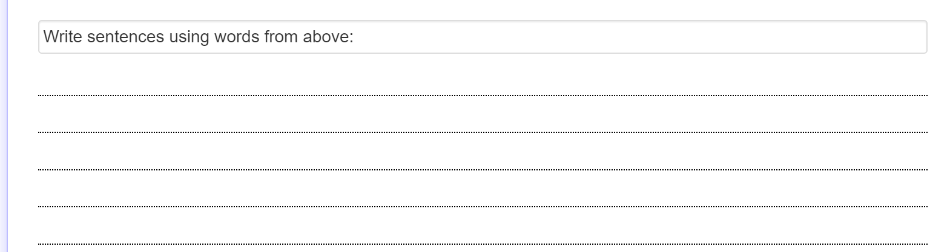

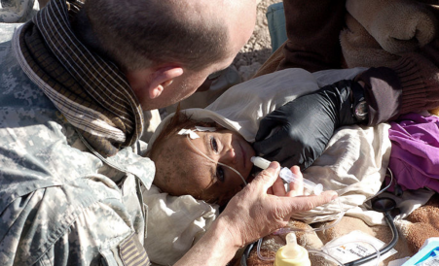Malnutrition

Malnutrition is a ****disorder**** of your **[food intake](https://www.english-online.at/health_medicine/nutrition/nutrition-how-the-body-uses-food.htm)**. It ****occurs**** when a person eats too little or too much, or has an ****unbalanced diet****. In most cases malnutrition means ****undernourishment****, a ****lack**** of food and not enough calories. It is ****widespread**** in ****developing countries****. On the other side ****obesity**** occurs in ****developed countries**** where people eat too much. ****According to**** the World Health Organization malnutrition is one of the greatest dangers of ****global**** health. ****Currently****, about one ****billion**** people around the world do not have enough to eat.

### **When does malnutrition occur**

Malnutrition happens when people ****lack**** ****nutrients****, [vitamins](https://www.english-online.at/health_medicine/vitamins/vitamins and vitamin-supplements.htm) and minerals. Not enough ****proteins**** can have negative effects on a person’s growth and lead to ****physical**** problems. Vitamins are important for good health and the ****functioning**** of your body. A lack of them can cause ****major**** problems. Vitamin A ****deficiency**** may lead to eye problems and blindness. A lack of calcium leads to a bad growth of [bones](https://www.english-online.at/biology/bones/human-bones.htm) and [teeth](https://www.english-online.at/biology/teeth/human-teeth.htm). ****Iron deficiency**** can ****affect**** the **[brain](https://www.english-online.at/biology/human-brain/parts-and-functions-of-the-brain.htm)** and lead to a lower IQ rate. It can make children less active and not able to concentrate.

Malnutrition ****increases**** the risk of ****diseases**** and weakens the immune system. It ****affects**** the ****transmission**** of viruses, ****including**** [HIV](https://www.english-online.at/health_medicine/aids/growth-causes-of-aids.htm). It is ****especially**** ****widespread**** among women, children and older people. Children can be at risk even before birth because they ****depend**** on the mother’s ****nutrition****.

One in ten people around the world is ****malnourished****. Eating disorders ****account**** for 60 million deaths a year, including six million children. It is the main ****cause**** of child ****mortality****.

### **Causes of malnutrition**

One of the major ****causes**** of malnutrition in [developing countries](https://www.english-online.at/geography/developing-countries/characteristics-of-developing-countries.htm) is ****famine**** and ****drought**** which lead to the ****unavailability**** of food. Many countries in the Third World to not have enough land to grow [food](https://www.english-online.at/health_medicine/nutrition/nutrition-how-the-body-uses-food.htm) on or do not know how to use it. They do not have the money to ****afford**** imported food. In other countries the government ****neglects**** the importance of ****agriculture**** and does not help famers.

In places with a lack of or dirty drinking [water](https://www.english-online.at/geography/water/water-cycle-treatment.htm) diseases, like ****diarrhea****, lead to ****indigestion**** of food.

****Digestive disorders**** may also be causes of malnutrition. People eat properly but their body cannot ****digest**** the food. In the Third World many mothers do not ****breastfeed**** their children, thus ****weakening**** the immune system.

### **Signs of malnutrition**

* tiredness and not enough energy
* ****decaying**** teeth
* poor growth
* ****weight loss****
* ****fragile**** bones that break easily
* weakening of ****muscles****
* diarrhea
* ****dizziness****

### Depression **Obesity**

In developed countries ****obesity**** is the most ****widespread**** form of malnutrition. Obese people ****consume**** more calories than they need. This may lead to **[diabetes](https://www.english-online.at/health_medicine/diabetes-causes-syptoms-treatment/diabetes.htm)** and ****contribute**** to [heart](https://www.english-online.at/biology/human-heart/heart-and-diseases.htm) problems and [high](https://www.english-online.at/health_medicine/high-blood-pressure/high-blood-pressure-silent-killer.htm)**[blood pressure](https://www.english-online.at/health_medicine/high-blood-pressure/high-blood-pressure-silent-killer.htm)**. Too many fats in your diet can lead to high  ****cholesterol****levels.

## 

### **Solutions and Treatment**

One way to help ****avoid**** malnutrition is to ****enrich**** food with vitamins. For example, milk is enriched with Vitamin D. In Third World countries schools must try to teach children the right eating ****habits**** and ****emphasize**** eating vegetables and fruit. ****Governments**** and other institutions must do their part in educating the population to eat the right things. The World Health Organization and other groups try to help the poorest of these countries with financial ****aid**** and other support.

### **Word Bank**

* ****account for**** = to be  responsible for
* ****affect**** = have an influence on
* ****afford**** = to have the money to buy something
* ****agriculture**** = farming
* ****aid**** = help
* ****avoid**** = stop
* ****billion**** = a thousand million
* ****blood pressure**** = the power with which blood travels through  your body
* ****brain**** = organ inside your head that controls how you feel and think
* ****breastfeeding**** = to give a baby milk from its mother’s breast instead of from a bottle
* ****cause**** = reason
* ****cholesterol**** = chemical substance that is in your blood; too much of it can lead to heart problems
* ****consume**** = take in
* ****contribute**** = lead to
* ****currently**** = at the moment
* ****decay**** = to be damaged in a natural way
* ****deficiency**** = not enough of something
* ****depend on**** = need
* ****developed countries**** = rich countries in Europe, North America, as well as Japan and Australia
* ****developing countries**** = poor countries of Africa, Asia and Latin America
* ****diabetes**** = disease in which there is too much sugar in your blood
* ****diarrhea**** = illness in which waste comes out of your body in a watery form
* ****digest**** = to change the food into substances your body can use
* ****disorder**** = an illness that stops your body from working the way it should
* ****dizziness**** = feeling unable to stand steadily
* ****drought**** = long period of dry weather when there is not enough rainfall
* ****emphasize**** = highlight, stress, call to attention
* ****enrich**** = to make better
* ****especially**** = above all
* ****famine**** = a situation in which many people die  of hunger or have little food for a long time
* ****food intake**** = what you eat
* ****fragile**** = not strong
* ****functioning**** = how something works
* ****global**** = worldwide
* ****government**** = people who rule a country
* ****habit**** = routine ; what you do every day
* ****including**** = also
* ****increase**** = if something goes up
* ****indigestion**** = pain that you get when you your stomach cannot break down the food and use it the way it should
* ****iron**** = metal that is found in very small quantities in food and blood
* ****lack**** = not enough, shortage of
* ****major**** = important
* ****malnourish**** = not having the right things to eat
* ****mortality**** =  the number of deaths among a certain group of people in a year
* ****muscle**** = pieces of flesh that you use to move things and which connect your bones together
* ****neglect**** = not care about
* ****nutrient**** = chemical or food that gives us what we need to survive
* ****nutrition**** = food
* ****obesity**** = being fat in an unhealthy way
* ****occur**** = happen
* ****physical**** = about the body
* ****protein**** = a natural substance that is in meat, eggs and beans and that our body needs to grow in the right way
* ****unavailability**** = when something does not exist
* ****unbalanced diet**** = too much of the same kind of food
* ****undernourishment**** = to be healthy and weak because you have not had enough to eat
* ****weakening**** = to make weaker
* ****weight loss**** = to lose weight
* ****widespread**** = very common

|  |  |  |
| --- | --- | --- |
| 单词：词性 | 文中释义 | 文中搭配 |
| Jewel n. | 珠宝 | Tropical rainforests have been called the "jewels of the Earth" |
|  |  |  |
|  |  |  |
|  |  |  |
|  |  |  |
|  |  |  |
|  |  |  |
|  |  |  |
|  |  |  |
|  |  |  |
|  |  |  |
|  |  |  |
|  |  |  |
|  |  |  |
|  |  |  |
|  |  |  |
|  |  |  |
|  |  |  |



**Amazon.Com - The World's Largest Internet Company**

Amazon.com is the world's largest [Internet](https://www.english-online.at/media/internet/the-internet-and-its-use.htm) company. It started out as an online bookstore in the middle of the 1990s and grew ****gradually**** over the years. Today Amazon sells almost everything from CDs and DVDs to ****sportswear**** and electrical ****appliances****. The company also produces its own ****tablets**** and [e-readers](https://www.english-online.at/media/ebooks/are-we-ready-for-ebooks.htm) and lets users upload their own photos and other files to the ****Amazon-based**** ****cloud****.

Amazon offers its ****services**** all over the world. It ****operates**** its own websites in the UK, Germany, China, [Australia](https://www.english-online.at/geography/australia/australia-introduction.htm), as well as many South American and Asian countries.

Amazon.com was ****founded**** by Jeff Bezos in 1994. It first ****operated**** out of a small garage in Washington state. Within a year Amazon offered hundreds of thousands of books. People could not only order books from an online catalogue but also write their own ****reviews****. In 1997 Amazon.com started trading ****shares**** on the NASDAQ **[stock exchange](https://www.english-online.at/economy/stocks-and-bonds/stocks-and-stock-exchange.htm)**. By 2000 it made over a ****billion**** dollars in ****sales****.

As time went on Amazon.com grew ****gradually****. It bought many of its ****rivals**** and today ****cooperates**** with other companies and lets them sell their products via the Amazon website.

In 2007 Amazon went a step further. It surprised the electronics world with a ****revolutionary**** eBook reader, the *Kindle*, which today ****dominates**** the market. In 2011 a tablet computer followed, the Amazon *Fire*. In the following years the company started selling music downloads and ****videos on demand****. Amazon ****customers**** can ****store**** everything they buy on their private cloud and download it anytime they want.

Today, Amazon.com ****serves**** 20 million ****customers**** every day. Its ****annual income**** is over 34 billion dollars.

There are a number of reasons for Amazon’s success. One of them is company ****founder**** Jeff Bezos himself. *TIME* magazine’s “*Man of the Year*” of 1999 is a ****visionary****, an ****ambitious**** businessman who is not afraid of taking risks, even if it means a ****downturn**** for the company at first. Amazon’s website tries to ****personalize**** the buying ****experience**** for its customers. It knows what you want and what you are interested in.

****Although**** Amazon.com is the biggest internet ****retailer**** in the world it is often criticized. Economic experts say that Amazon is turning Internet business into a ****monopoly****. Others ****point out**** the bad working ****conditions**** for Amazon ****employees****.

Amazon is a business ****empire**** that sells almost anything cheaper and faster than anyone else.

### **Word bank**

* ****although**** = while
* ****Amazon-based**** = here: something that only works with Amazon and its own computers
* ****ambitious**** = hard-working, very motivated
* ****annual**** = yearly
* ****appliance**** = machine that you use for doing something at home
* ****billion**** = a thousand million
* ****cloud**** = when you work on your own computer but use software or store files on other computers on the Internet
* ****condition****= situation
* ****cooperate**** = work together with
* ****customer**** = a person who buys a product
* ****dominate**** = control, lead
* ****downturn**** = here: sales go down
* ****empire**** = here: very large company or group of companies
* ****employee**** = worker
* ****experience**** = event, something that happens
* ****found – founded**** = start something new
* ****gradually**** = slowly
* ****income**** = the money you get from selling products
* ****monopoly**** = a large company that controls all or most of the business
* ****operate**** = work
* ****personalize**** = to organize something so that it fits the habits of a certain person
* ****point out**** = want to show
* ****retailer**** = person that sells products to customers
* ****review**** = an opinion about a book, movie etc..
* ****revolutionary**** = something new or not done before
* ****rival**** = other company that wants to sell the same products
* ****sales**** = selling products
* ****serve**** = sell products to
* ****services**** = what a company offers its customers
* ****share**** = part of a company
* ****sportswear**** = clothes you need for doing sports
* ****stock exchange**** = a place where you can buy and sell parts of a company
* ****store**** = save something in order to use it later
* ****tablet**** = small computer with a touch screen, but without a keyboard and mouse
* ****video on demand**** = you can download a video to watch on your computer or TV whenever you want to
* ****visionary**** = someone who has clear ideas and strong feelings about the future

|  |  |  |
| --- | --- | --- |
| 单词：词性 | 文中释义 | 文中搭配 |
| Jewel n. | 珠宝 | Tropical rainforests have been called the "jewels of the Earth" |
|  |  |  |
|  |  |  |
|  |  |  |
|  |  |  |
|  |  |  |
|  |  |  |
|  |  |  |
|  |  |  |
|  |  |  |
|  |  |  |
|  |  |  |
|  |  |  |
|  |  |  |
|  |  |  |
|  |  |  |
|  |  |  |
|  |  |  |

练习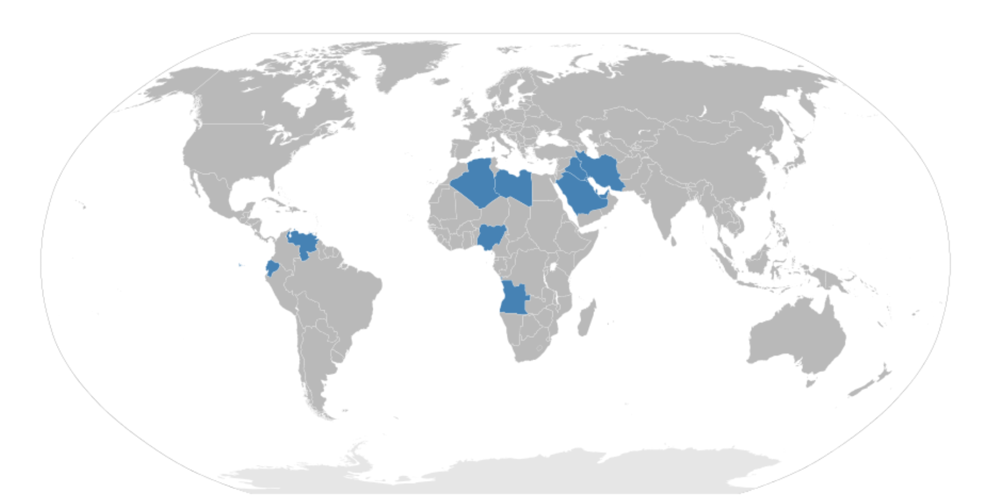OPEC is the Organization of ****Petroleum**** Exporting Countries. It was ****founded**** in Bagdad in 1960 and has ****currently**** 11 members.  OPEC’s ****aim**** is to ****regulate**** the ****amount**** of [oil](https://www.english-online.at/biology/oil/oil-petroleum.htm) that member nations produce and to keep prices at a ****steady rate****. The countries get together ****twice**** a year and ****agree on**** how much oil each country is allowed to produce. OPEC’s ****headquarters**** are in Vienna, the ****capital**** of Austria.

Before OPEC was created, there were large oil companies that controlled the world’s oil production. They wanted to sell as much oil as possible and did not let ****governments**** ****influence**** their ****decisions****.  Oil-rich countries, ****especially**** in the Middle East, wanted more control over the oil that they produce. ****As a result,**** Iran, [Iraq](https://www.english-online.at/current_affairs/inside-iraq/history-geography-of-iraq.htm), Saudi Arabia, Kuwait and Venezuela ****founded**** OPEC. In the following years Qatar, Indonesia, Libya, Algeria, Nigeria, Ecuador, Angola and the United Arab Emirates also become members.

In the [1960s](https://www.english-online.at/history/1960s/society-and-change-in-the-sixties.htm), OPEC did not have much power. This changed in 1973 when the third [Arab-Israeli war](https://www.english-online.at/current_affairs/arab-israeli-conflict/conflict-in-the-middle-east.htm) started. The United States and a few European countries ****supported**** Israel.  As a form of ****punishment****, OPEC nations, ****influenced**** by the Arab countries, stopped selling oil to the West. Within the next six years oil prices ****rose**** to ten times the price of the early 1970s. OPEC countries became rich with so-called ****petrodollars****; the West sank into deep ****recession**** because they needed OPEC’s oil.

In the ****aftermath**** of the energy crisis of the 1970s, western countries started looking for **[alternative](https://www.english-online.at/geography/energy/alternative-energy-sources.htm)**[forms of energy](https://www.english-online.at/geography/energy/alternative-energy-sources.htm) in order to become more ****independent**** from OPEC and the oil-producing nations. In 1986, oil prices ****dropped**** to the lowest ****rate**** in history. Oil-producing nations lost much of their ****income****.  In the 80s and 90s OPEC’s power ****diminished****, often because of conflicts and ****internal**** ****arguments**** and because member states could not agree on ****production**** ****quotas****. Some OPEC countries did not keep ****agreements**** and produced more oil, ****thus**** lowering prices.

After 2000, oil prices began to ****rise**** again and reached an ****all-time high**** in 2007. The [financial crisis of 2007 and 2008](https://www.english-online.at/economy/global-economic-crisis/financial-crisis-2008.htm) hit world ****economy**** hard and oil prices fell once again. Since the [Arab Spring of 2011](https://www.english-online.at/current_affairs/arab-spring/rebellions-in-north-africa-and-middle-east.htm), prices have gone up and down ****several**** times.

Today OPEC still controls about 60% of the world’s oil ****reserves**** and produces 40% of the world’s oil. Saudi Arabia is the most powerful member of the group, because it has the largest reserves. ****Even though**** there have been ****quarrels**** in the ****cartel**** in the last 5 decades it ****remains**** a powerful organization.

**Words**

* ****aftermath**** = what comes after a special event
* ****agree on**** =  decide, come to a decision
* ****agreement**** = promise, deal
* ****aim**** = goal; what somebody wants to do
* ****all-time high**** = the highest price  in history
* ****alternative**** = other, new
* ****amount**** = how much of a product
* ****argument**** = quarrel, fight
* ****as a result**** = that is why
* ****capital**** = most important city of a country; in which the government is
* ****cartel**** = countries that agree to sell something at the same price
* ****currently**** = right now, at the moment
* ****decision**** = deciding something
* ****diminish**** = become less, weaker
* ****drop****= go down
* ****economy**** = the system by which a country’s money and goods are produced and used
* ****especially**** = above all
* ****even though**** = while
* ****found-founded**** = start, create something new
* ****government**** = people who rule a country
* ****headquarters**** = the main building of an organization
* ****income**** = the money you get for selling products
* ****independent**** = free
* ****influence**** = power, control
* ****internal**** = between member countries
* ****petrodollars**** = money that you get by selling oil
* ****petroleum**** = oil
* ****production quota**** = official limit on how much a country can produce
* ****punishment**** = penalty; to make someone suffer because they have done something wrong
* ****quarrel**** = argument, fight
* ****rate**** = here: price
* ****recession**** = difficult time in business, when there is less production and people do not earn enough money and buy things
* ****regulate**** = control
* ****remain**** = stay
* ****reserves**** = here: the oil that probably is in the ground and can be produced in the future
* ****rise – rose- risen**** = go up
* ****several**** = a few
* ****steady rate**** = stable price
* ****support**** = help; assist
* ****thus**** = therefore

A ****research**** report says that ****virtual**** worlds can be important places where children practice what they will do in real life. They are also a powerful and ****attractive**** alternative to more passive adventures like watching TV. The ****research**** was done with children using the BBC's Adventure Rock virtual world, ****aimed**** at those aged 6-12.It ****surveyed**** and interviewed children who were the first to test the game.

The online world is a ****theme island**** built for the BBC's children channel by Belgian game maker Larian. Children ****explore**** the world alone but they use message boards to ****share**** what they find and what they do in the different ****creative**** studios they find around the ****virtual space****.

At times children were ****explorers**** and at others they were ****social**** climbers eager to ****connect**** with other players. Some were power users looking for more information about how the ****virtual space**** really worked. The children could try all kinds of things without having to be afraid of the ****consequences**** that would follow if they tried them in the real world. They learned many useful ****social skills**** and played around with their identity in ways that would be much more difficult in real life.

****According to**** the study what children liked about virtual worlds was the chance to ****create**** ****content**** such as music, cartoons and videos.

The ****publishers**** of the report say that virtual worlds can be a powerful, ****engaging**** and real interactive alternative to more passive media. They ****urged**** creators of virtual spaces for children to get young people ****involved**** very early on because they really do have good ideas to add and they are very good critical friends.

### **Words**

* ****according**** = as shown by someone or said by someone
* ****aim**** = target
* ****attractive**** = here: to have good qualities
* ****connect**** = meet
* ****consequences**** = result, outcome
* ****content**** = here: facts, ideas, opinions
* ****creator**** = a person who makes something
* ****eager**** = ready , waiting to do something
* ****engaging**** = here: to make interesting
* ****explore**** = to travel around a place and find out things about it
* ****involved**** = here: to make young people play the game
* ****power user**** = here: a child who plays a lot with the game
* ****publisher**** = person who shows the report to the people
* ****research**** = the study of a subject to find out new facts about it
* ****social skills**** = things that you will need when you later work with or get into contact with other people
* ****survey**** = to ask people about what they think
* ****theme island**** = here: an island with many different topics
* ****urge**** = tell someone to do something
* ****useful**** = things that you can use
* ****virtual space**** = a world that is not real



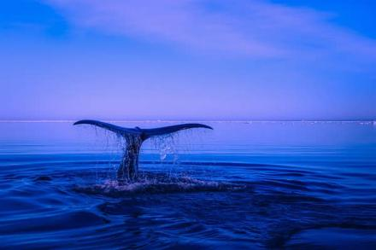  **Do whale sleep?**

whales can be described as follows:

* Like all mammals, whales breathe air,
* They are warm-blooded,
* They nurse their young with milk,
* They have body hair.
* Whales have a four-chambered heart.

读前猜词： whale， mammal， respiratory system

Whales are mammals, so in many ways, they are just like human beings. The most important difference is that humans and whales live in different environments and whales have a special respiratory system that enables them to stay underwater for several minutes without breathing oxygen. For this reason, they are said to be voluntary breathers. That is, because of whales underwater environment, they must be conscious breathers. They think about every breath they take and come up to the surface of the water to breathe through blowholes on top of their heads.

What is outstanding about whales is the way they can sleep. While all mammals sleep, whales cannot afford to become unconscious for long because they may drown. The only way they can sleep is by remaining partially conscious. It is believed that only one hemisphere of the whale's brain sleeps at a time, so they rest but are never completely asleep. They can do so most probably near the surface so that they can come up for air easily.

1. Whales are like fish in the way they breathe.  
   a.  True  
   b.  False
2. Whales don't sleep at all.  
   a.  True.  
   b.  False.
3. Whales sleep by letting the whole brain rest for a lapse of time.  
   a. True  
   b.  False

List as many mammals as you can

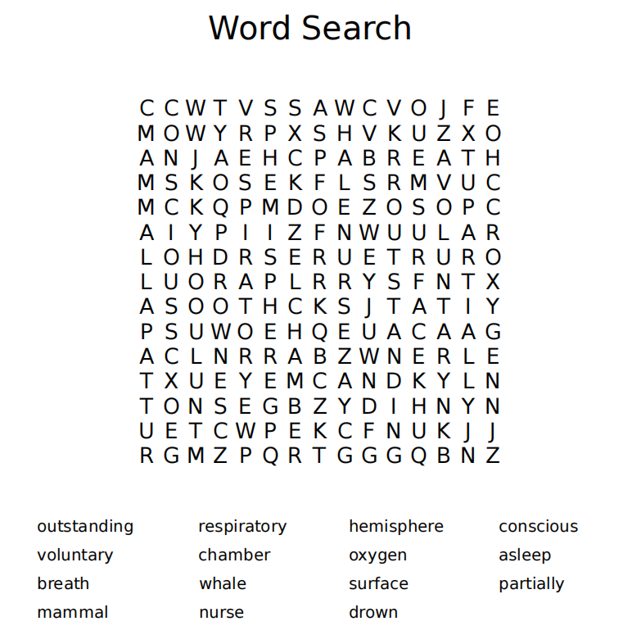

Mammal：

Synonym:

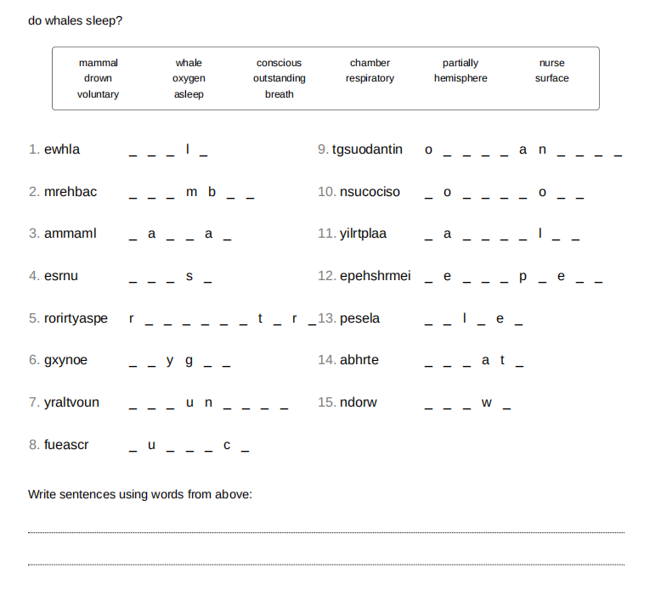

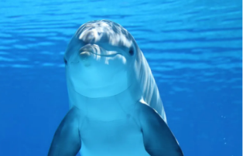Dolphins social behavior

Dolphins are often regarded as one of Earth's most intelligent animals. They are social creatures, living in pods of up to a dozen individuals. In places with a high abundance of food, pods can merge temporarily, forming a ****superpod****; such groupings may exceed 1,000 dolphins. They communicate using a variety of clicks, whistle-like sounds and other vocalizations.

Membership in pods is not rigid; interchange is common. Dolphins can, however, establish strong social bonds; they will stay with injured or ill individuals, even helping them to breathe by bringing them to the surface if needed. This altruism does not appear to be limited to their own species. The dolphin Moko in New Zealand has been observed guiding a female Pygmy Sperm [Whale](https://www.myenglishpages.com/english/reading-whale.php) together with her calf out of shallow water where they had stranded several times. They have also been seen protecting swimmers from sharks by swimming circles around the swimmers or charging the sharks to make them go away.

Dolphins also display culture, something long believed to be unique to humans. In May 2005, a discovery in Australia found Indo-Pacific bottlenose dolphins (Tursiops aduncus) teaching their young to use tools. They cover their snouts with sponges to protect them while foraging (looking or searching for food or provisions.) Using sponges as mouth protection as well as other transmitted behavior proves dolphins' intelligence. This knowledge is mostly transferred by mothers to daughters.

1. Dolphins are solitary creatures.   
   a.  True  
   b.  False
2. Dolphins are selfish.   
   a.  True.  
   b.  False.
3. Dolphins teach each other some behaviors.  
   a.  True  
   b.  False

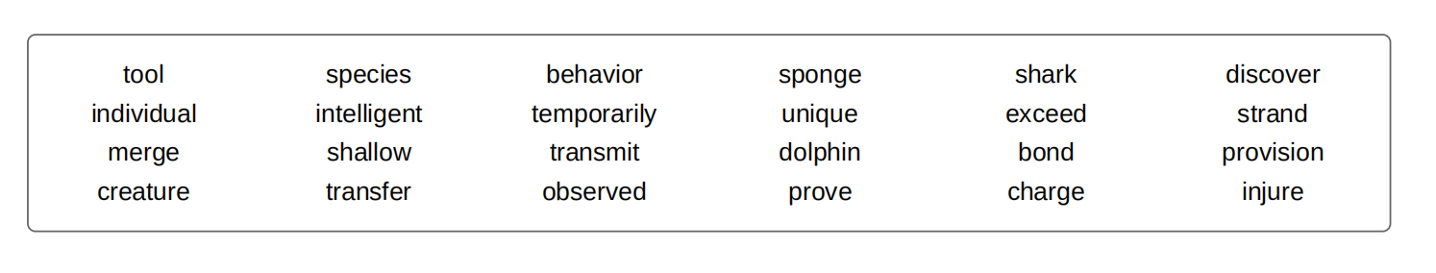

Synonym：

Discover

Individual

Creature

Shallow

Intelligent

Injure

Unique List as many tools as you can:

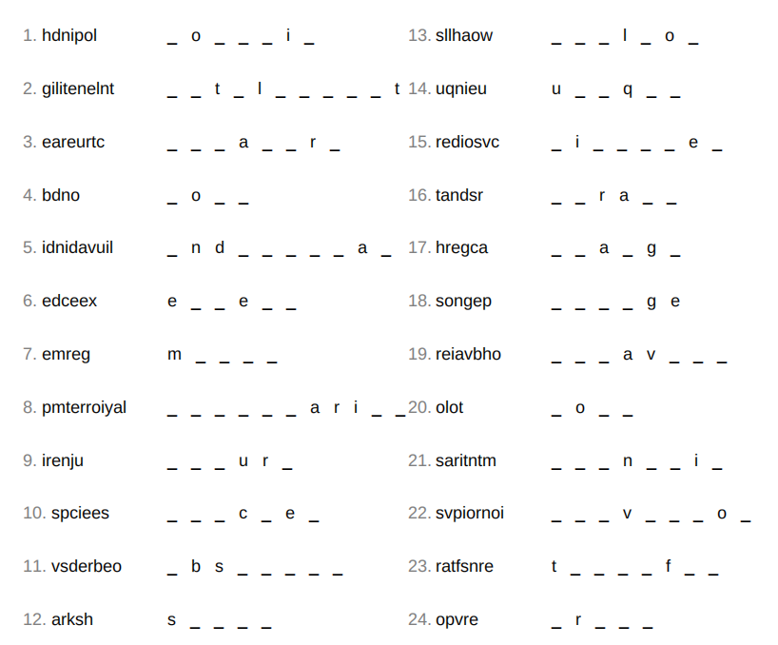

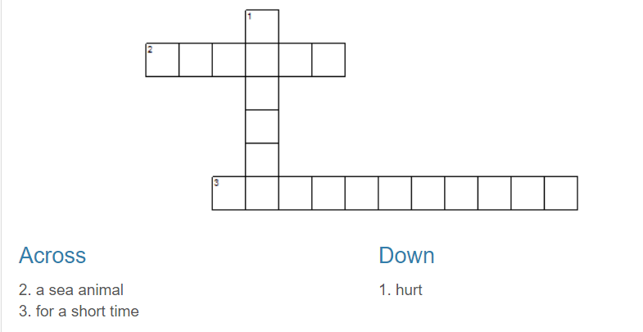

### [IMG_256](https://commons.wikimedia.org/wiki/File:Taman-Negara.jpg)What are rainforests?

****Rainforests**** are forests characterized by biodiversity and high rainfall, with annual rainfall between 250 and 450 centimeters (98 and 177 in). There are two types of rainforest: tropical rainforest and temperate rainforest. ****Tropical rainforests**** are characterized by a warm and wet climate with no substantial dry season: typically found within 10 degrees north and south of the equator in areas such as South America, Southeast Asia and Sub-Saharan Africa. ****Temperate rainforests****, however, are only found in few temperate regions around the world such as Europe, North America and East Asia.

#### Biodiversity

Around 40% to 75% of all biotic species are indigenous to the rainforests. It has been estimated that there may be many millions of species of plants, insects and microorganisms still undiscovered in tropical rainforests. Tropical rainforests have been called the "jewels of the Earth" and the "world's largest pharmacy", because over one quarter of natural medicines have been discovered there. Rainforests are also responsible for 28% of the world's oxygen turnover; that is why ropical forests are also called "Earth's lungs."

#### Economy

Rainforests produce many items that we all use in our daily lives. Tropical rainforests provide timber as well as animal products such as meat and hides. Other common rainforests products include: chocolate, sugar, cinnamon, rubber, medicine, and pineapples. Rainforests also have value as tourism destinations and for the ecosystem services provided.

Tropical forests are found only in tropical regions.  
a.  True  
b.  False

Many species of plants, insects and microorganisms haven't been discovered in tropical rainforests yet.  
a.  True  
b.  False

Rainforests have contributed to economic development.  
a.  True  
b.  False

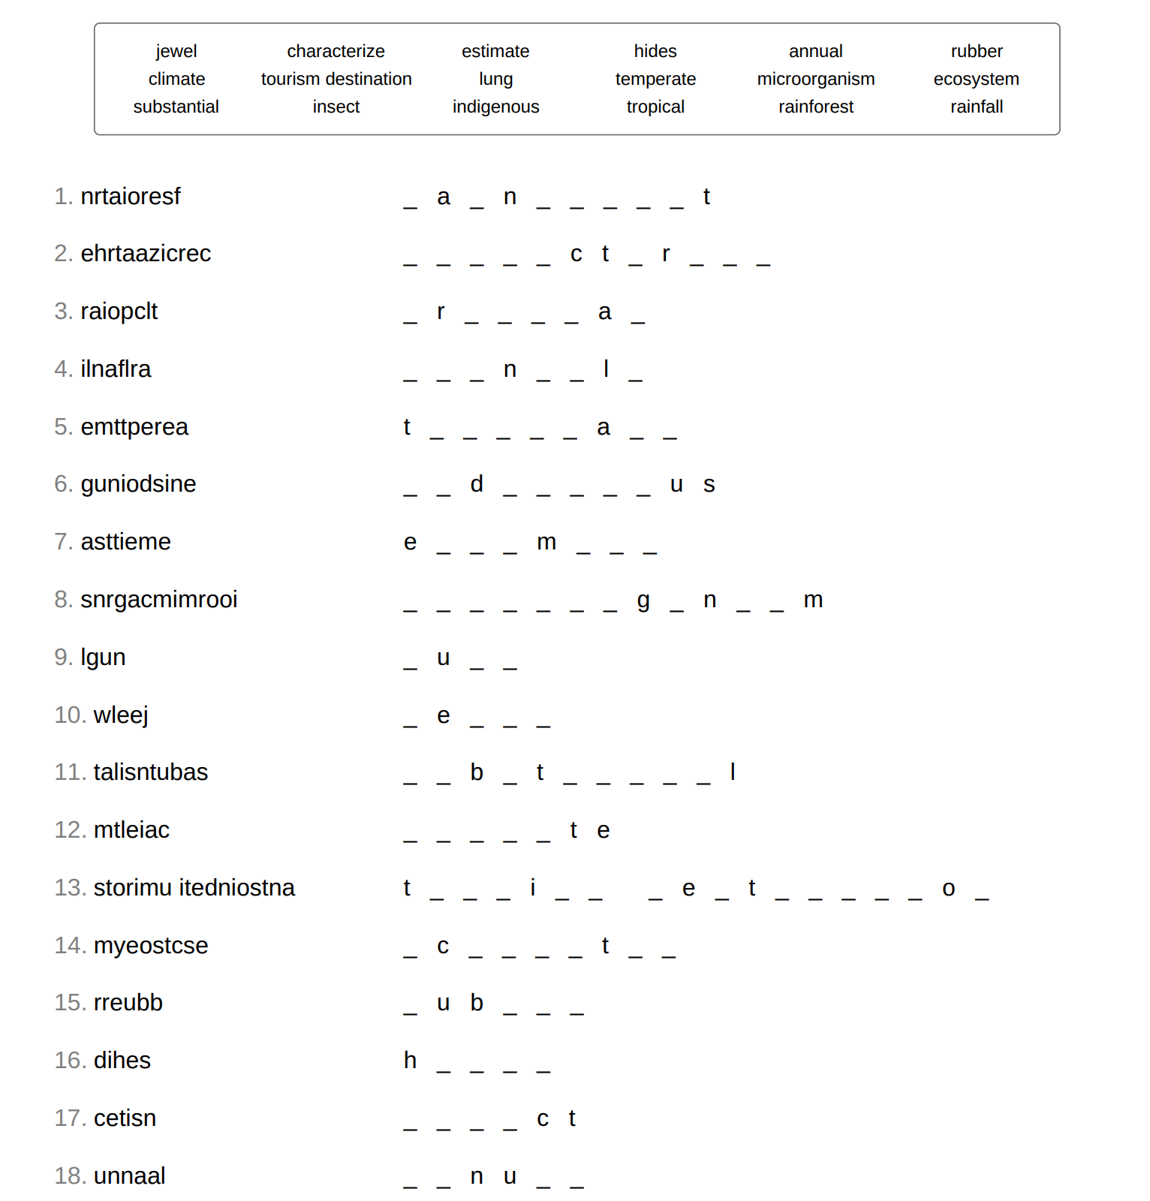

### [IMG_256](https://commons.wikimedia.org/wiki/File:Walt_disney_portrait.jpg)Walt Disney

****Walt Disney**** was born on December 5, 1901. Disney became one of the best-known motion picture producers in the world. He is particularly noted for being a film producer and a popular showman, as well as an innovator in animation and theme park design.

Disney is famous for his contributions in the field of entertainment during the 20th century. His first success was through the series, Oswald the Lucky Rabbit which was created by the ****Disney studio**** for Charles Mintz of Universal Studios. When Disney asked for a larger budget for his popular Oswald series, Mintz refused and Disney had to quit. Later, Disney and his brother Roy O. Disney started from scratch and co-founded Walt Disney Productions, now known as ****The Walt Disney Company****. Today, this company has annual revenues of approximately U.S. $35 billion. This succes is largely due to a number of the world's most famous fictional characters he and his staff created including [Mickey Mouse](https://www.myenglishpages.com/english/reading-mickey-mouse.php), a character for which Disney himself was the original voice.

Disney won 26 Academy Awards out of 59 nominations, including a record four in one year, giving him more awards and nominations than any other individual. He is also the namesake for Disneyland and Walt Disney World Resort theme parks in the United States, as well as the international resorts in Japan, France, and China.

Disney died of lung cancer in Burbank, California, on December 15, 1966. The following year, construction began on Walt Disney World Resort in Florida. His brother Roy Disney inaugurated The Magic Kingdom on October 1, 1971.

The following is a list of some of Walt Disney best quotes:

"All our dreams can come true, if we have the courage to pursue them."

"I always like to look on the optimistic side of life, but I am realistic enough to know that life is a complex matter."

"I do not like to repeat successes, I like to go on to other things."

"I have been up against tough competition all my life. I wouldn't know how to get along without it."

"If you can dream it, you can do it."

"The way to get started is to quit talking and begin doing."

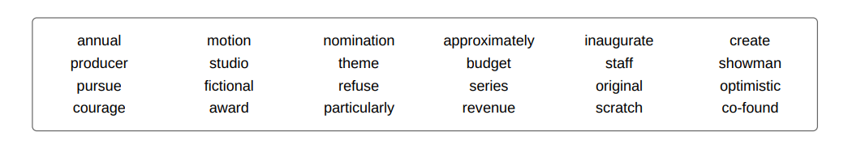

|  |  |  |
| --- | --- | --- |
| 单词：词性 | 文中释义 | 文中搭配 |
|  |  |  |
|  |  |  |
|  |  |  |
|  |  |  |
|  |  |  |
|  |  |  |
|  |  |  |
|  |  |  |
|  |  |  |
|  |  |  |
|  |  |  |
|  |  |  |
|  |  |  |
|  |  |  |
|  |  |  |
|  |  |  |
|  |  |  |
|  |  |  |
|  |  |  |
|  |  |  |
|  |  |  |
|  |  |  |
|  |  |  |
|  |  |  |
|  |  |  |

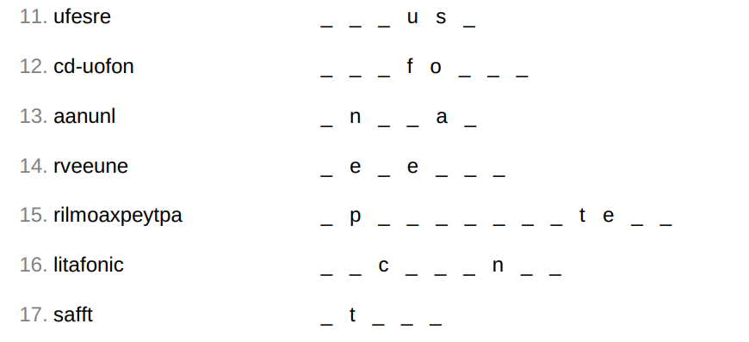

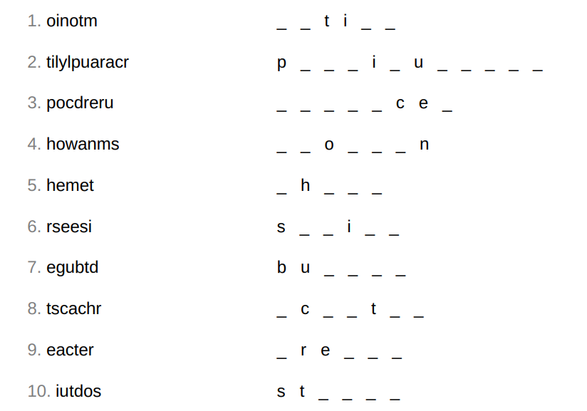

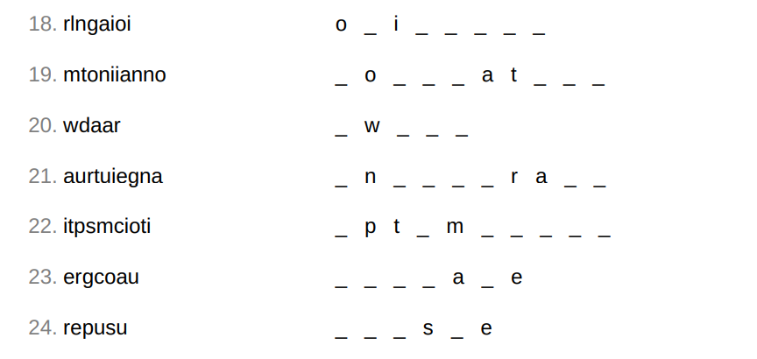

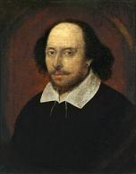

****William Shakespeare**** was an English poet, playwright, and actor. He was born on 26 April 1564 in Stratford-upon-Avon. His father was a successful local businessman and his mother was the daughter of a landowner. Shakespeare is widely regarded as the greatest writer in the English language and the world's pre-eminent dramatist. He is often called England's national poet and nicknamed the Bard of Avon. He wrote about 38 plays, 154 sonnets, two long narrative poems, and a few other verses, of which the authorship of some is uncertain. His plays have been translated into every major living language and are performed more often than those of any other playwright.

#### Marriage and career

Shakespeare married Anne Hathaway at the age of 18. She was eight years older than him. They had three children: Susanna, and twins Hamnet and Judith. After his marriage information about his life became very rare. But he is thought to have spent most of his time in London writing and performing in his plays. Between 1585 and 1592, he began a successful career in London as an actor, writer, and part-owner of a playing company called the Lord Chamberlain's Men, later known as the King's Men.

#### Retirement and death

Around 1613, at the age of 49, he retired to Stratford , where he died three years later. Few records of Shakespeare's private life survive. He died on 23 April 1616, at the age of 52. He died within a month of signing his will, a document which he begins by describing himself as being in "perfect health". In his will, Shakespeare left the bulk of his large estate to his elder daughter Susanna.

#### His work

Shakespeare produced most of his known work between 1589 and 1613. His early plays were mainly comedies and histories and these works remain regarded as some of the best work produced in these genres. He then wrote mainly tragedies until about 1608, including Hamlet, Othello, King Lear, and Macbeth, considered some of the finest works in the English language. In his last phase, he wrote tragicomedies, also known as romances, and collaborated with other playwrights.

Shakespeare's plays remain highly popular today and are constantly studied, performed, and reinterpreted in diverse cultural and political contexts throughout the world.

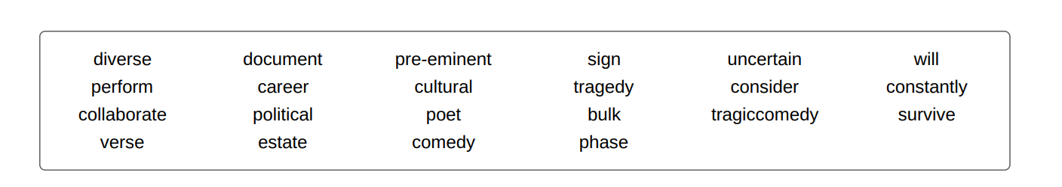

1. Shakespeare's parents were poor.  
   a.  True  
   b.  False
2. His wife was 18 when they got married.  
   a.  True  
   b.  False
3. Shakespeare died in Stratford.  
   a.  True  
   b.  False
4. In the last years of his life, he wrote mainly tragicomedies.  
   a.  True  
   b.  False

|  |  |  |
| --- | --- | --- |
| 单词：词性 | 文中释义 | 文中搭配 |
|  |  |  |
|  |  |  |
|  |  |  |
|  |  |  |
|  |  |  |
|  |  |  |
|  |  |  |
|  |  |  |
|  |  |  |
|  |  |  |
|  |  |  |
|  |  |  |
|  |  |  |
|  |  |  |
|  |  |  |

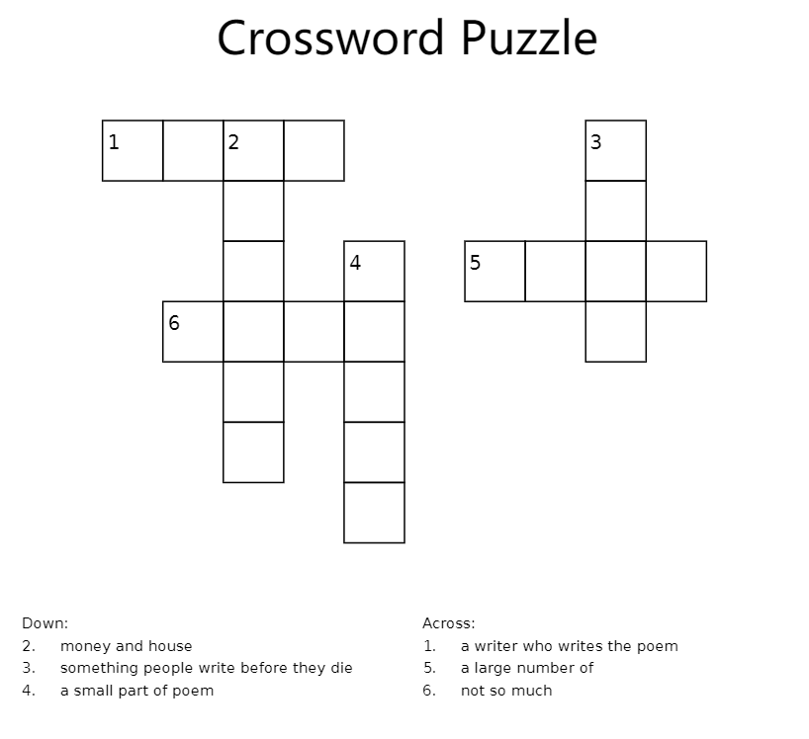

#### [IMG_256](https://commons.wikimedia.org/wiki/File:Charles_Dickens_3.jpg)Charles Dickens

****Charles Dickens**** was an English writer and social critic. During his lifetime, his works enjoyed unprecedented popularity. He is now considered a literary genius because he created some of the world's best-known fictional characters and is regarded as the greatest novelist of the Victorian era. His novels and short stories enjoy lasting popularity.

#### His early life

Dickens was born on February 7, 1812  in Portsmouth, on the southern coast of England. His father, John Dickens, was a naval clerk who dreamed of becoming rich and his mother, Elizabeth Barrow, aspired to be a teacher and school director. But the family’s financial situation had grown worse because John Dickens used to spend money dangerously beyond the family’s means. Consequently, John was sent to prison for debt in 1824, when Charles was just 12 years old.

After his father's imprisonment, Charles Dickens left school to work in a factory. Despite his lack of formal education, he edited a weekly journal for 20 years, wrote 15 novels, five novellas, hundreds of short stories and non-fiction articles, lectured and performed extensively, was an indefatigable letter writer, and campaigned vigorously for children's rights, education, and other social reforms.

#### His literary success

Dickens's literary success began with the 1836 serial publication of The Pickwick Papers. Within a few years he had become an international literary celebrity, famous for his humor, satire, and keen observation of character and society. His novels, most published in monthly or weekly instalments, pioneered the serial publication of narrative fiction, which became the dominant Victorian mode for novel publication.

Dickens was regarded as the literary colossus of his age. His 1843 novella, A Christmas Carol, remains popular and continues to inspire adaptations in every artistic genre. Oliver Twist and Great Expectations are also frequently adapted, and, like many of his novels, evoke images of early Victorian London. His 1859 novel, A Tale of Two Cities, set in London and Paris, is his best-known work of historical fiction.

#### His Death

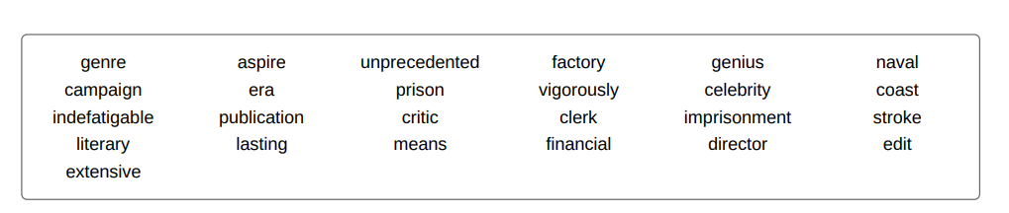Charles Dickens died on June 9, 1870 of a stroke. He was buried in Poet’s Corner at Westminster Abbey. Thousands of mourners came to pay their respects at the grave and throw in flowers.

1. Dicken's family was rich.  
   a.  True  
   b.  False

|  |  |  |
| --- | --- | --- |
| 单词：词性 | 文中释义 | 文中搭配 |
|  |  |  |
|  |  |  |
|  |  |  |
|  |  |  |
|  |  |  |
|  |  |  |
|  |  |  |
|  |  |  |
|  |  |  |
|  |  |  |
|  |  |  |
|  |  |  |
|  |  |  |
|  |  |  |
|  |  |  |
|  |  |  |
|  |  |  |
|  |  |  |
|  |  |  |
|  |  |  |
|  |  |  |
|  |  |  |
|  |  |  |

1. He left school at an early age.  
   a.  True  
   b.  False
2. His novels were characterized by realism.  
   a.  True  
   b.  False
3. He died due to a stroke.  
   a.  True  
   b.  False.

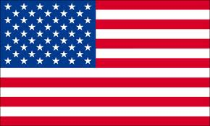

### The US political parties

There have usually only been two main political parties in the US. Since the 1860s, two main parties have been the Republican Party and the Democratic Party. It should be noted though that there are other minor parties such as the Libertarian Party, the Green Party, and Constitution Party.

#### The Democratic Party

The Democratic Party started in 1828 as a pro-slavery party with its Andrew Jackson as the first President in 1829. However, through the economic resurgence after the Great Depression in the 1930s and 1940s, as well as the Civil Rights Movement in the 1960s, the Democratic party became an advocate of racial equality. The party's philosophy of modern liberalism adopts social and economic equality principles. It aims at setting government intervention and regulation in the economy such as the introduction of social programs, support for labor unions, affordable college tuitions, universal health care, equal opportunity, consumer protection, and environmental protection.

#### The Republican party

The Republican party, however, started as an anti-slavery party in 1854. Its first President was Abraham Lincoln in 1861. In the Nixon years, there was a shift to appeal to the implicit racial biases of white voters that did not like the civil rights movement of the 1960s. The philosophy of the party focuses on social and economic independence, and a capitalist economic system. It is also known for its anti-abortion efforts, anti-regulatory policy, and reduction of government intervention in the economy as well as being in support of privatized health care.

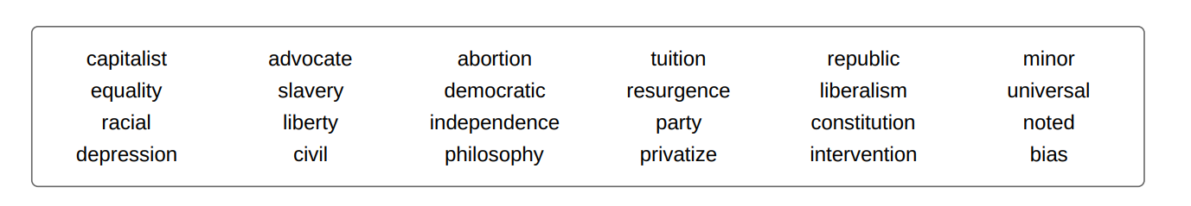

1. There are only two parties in the US.  
   a.  True  
   b.  False

|  |  |  |
| --- | --- | --- |
| 单词：词性 | 文中释义 | 文中搭配 |
|  |  |  |
|  |  |  |
|  |  |  |
|  |  |  |
|  |  |  |
|  |  |  |
|  |  |  |
|  |  |  |
|  |  |  |
|  |  |  |
|  |  |  |
|  |  |  |
|  |  |  |
|  |  |  |
|  |  |  |
|  |  |  |
|  |  |  |
|  |  |  |
|  |  |  |
|  |  |  |
|  |  |  |
|  |  |  |
|  |  |  |

1. The Democratic Party is a proponent of government intervention in the economy.  
   a.  True  
   b.  False



****UNICEF****

****UNICEF**** stands for ****United Nations International Children's Emergency Fund****. It was created by the United Nations General Assembly on December 11, 1946, to provide emergency food and health care to children in countries that had been devastated by World War II.

In 1954, UNICEF became a permanent part of the United Nations System. UNICEF relies on contributions from governments and private donors. Governments contribute two thirds of the organization's resources; private groups and some 6 million individuals contribute the rest through the National Committees. Most of UNICEF's work is in the field, with staff in over 190 countries and territories. More than 200 country offices carry out UNICEF's mission through a program developed with host governments. Seven regional offices provide technical assistance to country offices as needed.

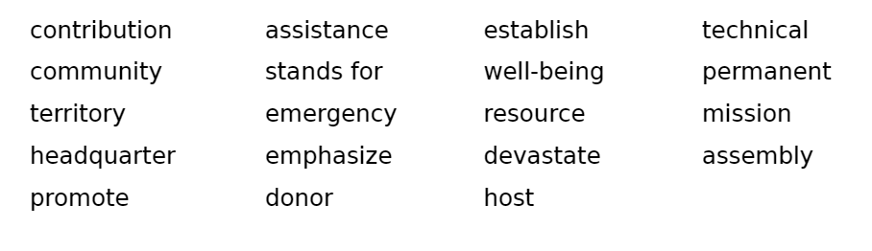UNICEF's programs emphasize developing community-level services to promote the health and well-being of children. UNICEF was awarded the Nobel Peace Prize in 1965 and the Prince of Asturias Award of Concord in 2006.

1. UNICEF was established before the end of world war II.  
   a.  True  
   b.  False
2. The organization relies only on governments contributions.  
   a.  True  
   b.  False
3. Most of UNICEF's work is in its headquarters.  
   a.  True  
   b.  False
4. UNICEF has won two awards so far.  
   a.  True  
   b.  False

|  |  |  |
| --- | --- | --- |
| 单词：词性 | 文中释义 | 文中搭配 |
|  |  |  |
|  |  |  |
|  |  |  |
|  |  |  |
|  |  |  |
|  |  |  |
|  |  |  |
|  |  |  |
|  |  |  |
|  |  |  |
|  |  |  |
|  |  |  |
|  |  |  |
|  |  |  |
|  |  |  |
|  |  |  |
|  |  |  |
|  |  |  |
|  |  |  |
|  |  |  |
|  |  |  |
|  |  |  |
|  |  |  |



### The work of art depicted in this image and the reproduction thereof are in the public domain worldwide. The compilation copyright is held by Zenodot Verlagsgesellschaft mbH and licensed under the GNU Free Documentation License - published in wikimedia.**Obesity**

Obesity is a medical condition in which excess body fat has accumulated to the extent that it may have an adverse effect on health, leading to reduced life expectancy and/or increased health problems. Body mass index (BMI), a measurement which compares weight and height, defines people as overweight (pre-obese) when their BMI is between 25 kg/m2 and 30 kg/m2, and obese when it is greater than 30 kg/m2.

Obesity increases the likelihood of various diseases, particularly heart disease, type 2 diabetes, breathing difficulties during sleep, certain types of cancer, and osteoarthritis. Obesity is most commonly caused by a combination of excessive dietary calories, lack of physical activity, and genetic susceptibility, although a few cases are caused primarily by genes, endocrine disorders, medications or psychiatric illness. Evidence to support the view that some obese people eat little yet gain weight due to a slow metabolism is limited; on average obese people have a greater energy expenditure than their thin counterparts due to the energy required to maintain an increased body mass.

The primary treatment for obesity is dieting and physical exercise. To supplement this, or in case of failure, anti-obesity drugs may be taken to reduce appetite or inhibit fat absorption. In severe cases, surgery is performed or an intragastric balloon is placed to reduce stomach volume and/or bowel length, leading to earlier satiation and reduced ability to absorb nutrients from food.

Obesity is a leading preventable cause of death worldwide, with increasing prevalence in adults and children, and authorities view it as one of the most serious public health problems of the 21st century. Obesity is stigmatized in much of the modern world (particularly in the Western world), though it was widely perceived as a symbol of wealth and fertility at other times in history, and still is in some parts of the world.

1. The statistics state that.  
   a.  although obesity is prevalent, it is not considered as a serious illness.  
   b.  obesity is considered as a serious illness.
2. Obese people  
   a.  may suffer from severe illnesses.  
   b.  may suffer from mild ailments.
3. Modern medicine  
   a.  can cure obesity.  
   b.  cannot cure it at all.
4. The best treatment for obesity is  
   a.  related to individuals lifestyle.  
   b.  medical.

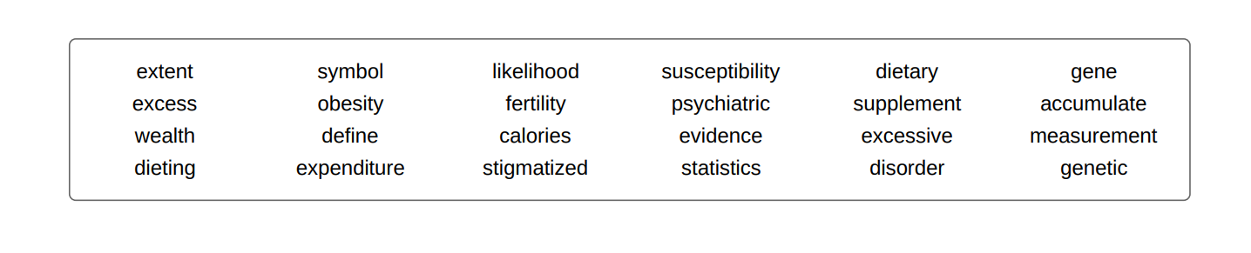

|  |  |  |
| --- | --- | --- |
| 单词：词性 | 文中释义 | 文中搭配 |
|  |  |  |
|  |  |  |
|  |  |  |
|  |  |  |
|  |  |  |
|  |  |  |
|  |  |  |
|  |  |  |
|  |  |  |
|  |  |  |
|  |  |  |
|  |  |  |
|  |  |  |
|  |  |  |
|  |  |  |
|  |  |  |
|  |  |  |
|  |  |  |
|  |  |  |
|  |  |  |
|  |  |  |
|  |  |  |
|  |  |  |



#### IMG_256Climate change

Climate encompasses the statistics of temperature, humidity, atmospheric pressure, wind, rainfall, atmospheric particle count and other meteorological elements in a given region over a long period of time. Climate can be contrasted to weather, which is the present condition of these same elements and their variations over shorter time periods.

Climate may be inherently variable as evidenced by the irregularity of the seasons from one year to another. This variability is normal and may remain partially understood. It is related to changes in ocean currents, volcanic eruptions, solar radiation and other components of the climate system. In addition, our climate also has its extremes (such as floods, droughts, hail, tornadoes and hurricanes), which can be devastating. However, in recent decades, a number of indicators and studies show more and more evidence of climate warming across the globe. A disturbing phenomenon that challenges human habits and activities which are responsible for greenhouse gas emissions.

#### Consequences of global warming

There are two major effects of global warming: the increase of temperature on the earth by about 3° to 5° C (5.4° to 9° Fahrenheit) by the year 2100 and Rise of sea levels by at least 25 meters (82 feet) by the year 2100. Other consequences are listed below:

* Sea levels are rising due to thermal expansion of the ocean, in addition to melting of land ice.
* Amounts and patterns of precipitation are changing.
* The total annual power of hurricanes has already increased markedly since 1975 because their average intensity and average duration have increased.
* Changes in temperature and precipitation patterns increase the frequency, duration, and intensity of other extreme weather events, such as floods, droughts, heat waves, and tornadoes.
* Higher or lower agricultural yields, further glacial retreat, reduced summer stream flows, species extinctions.
* Diseases like malaria are returning into areas where they have been extinguished earlier.

1. Climate is by definition variable.  
   a.  True  
   b.  False
2. Greenhouse effects have no impacts on our health.  
   a.  True  
   b.  False

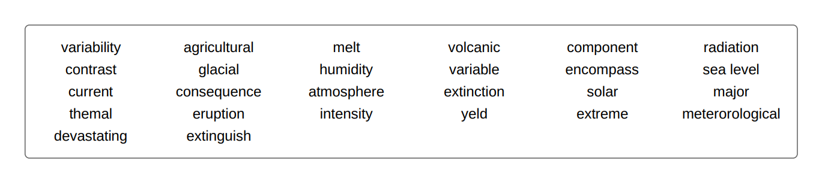

|  |  |  |
| --- | --- | --- |
| 单词：词性 | 文中释义 | 文中搭配 |
|  |  |  |
|  |  |  |
|  |  |  |
|  |  |  |
|  |  |  |
|  |  |  |
|  |  |  |
|  |  |  |
|  |  |  |
|  |  |  |
|  |  |  |
|  |  |  |
|  |  |  |
|  |  |  |
|  |  |  |
|  |  |  |
|  |  |  |
|  |  |  |
|  |  |  |
|  |  |  |
|  |  |  |
|  |  |  |
|  |  |  |





****ozone layer depletion****

The****ozone layer depletion**** is harmful to the environment. The ****ozone layer**** or ****ozone shield**** is a region of Earth's stratosphere that absorbs most of the Sun's ultraviolet (UV) radiation. It was discovered in 1913 by the French physicists Charles Fabry and Henri Buisson. The ozone layer contains high concentrations of ozone in relation to other parts of the atmosphere.

A depletion of the ozone layer has been noticed since the late 1970s. In atmospheric regions over Antarctica, the ozone layer has become significantly thin, especially in spring season causing the formation of what is called ‘ozone hole’. The main cause of ozone depletion and the ozone hole is man-made chemicals such as the chlorofluorocarbon (CFCs). As a consequence of the deterioration of the ozone layer, large amounts of ultraviolet B rays reach the Earth, which can cause skin cancer and cataracts in humans and harm animals as well.

The harmful consequences of ozone deterioration paved the way to the adoption of the Montreal Protocol in 1987. This protocol bans the production of CFCs, halons, and other ozone-depleting chemicals. The ban came into effect in 1989 and since then it has had positive effects on the environment. Ozone levels stabilized by the mid-1990s and began to recover in the 2000s. Recovery is projected to continue over the next century, and the ozone hole is expected to reach pre-1980 levels by around 2075. The Montreal Protocol is considered the most successful international environmental agreement to date.

1. The ozone layer was discovered in the 1970s.  
   a.  True  
   b.  False
2. The deterioration of the ozone layer started in the 21st century.  
   a.  True  
   b.  False
3. The harmful chemicals that caused the ozone layer depletion are not allowed to be produced anymore.  
   a.  True  
   b.  False
4. The ozone layer is still deteriorating.  
   a.  True  
   b.  False

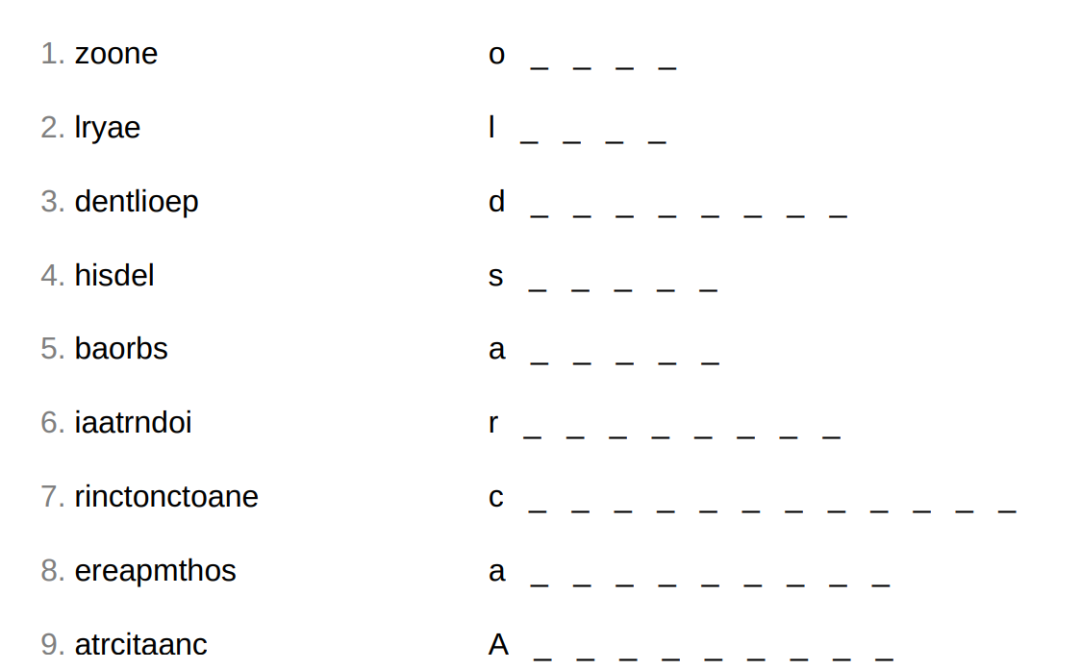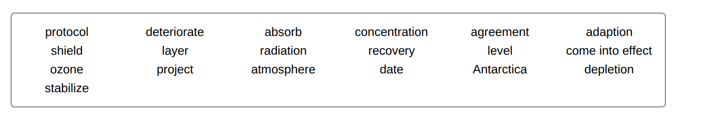

|  |  |  |
| --- | --- | --- |
| 单词：词性 | 文中释义 | 文中搭配 |
|  |  |  |
|  |  |  |
|  |  |  |
|  |  |  |
|  |  |  |
|  |  |  |
|  |  |  |
|  |  |  |
|  |  |  |
|  |  |  |
|  |  |  |
|  |  |  |
|  |  |  |
|  |  |  |
|  |  |  |
|  |  |  |
|  |  |  |
|  |  |  |
|  |  |  |
|  |  |  |
|  |  |  |
|  |  |  |
|  |  |  |



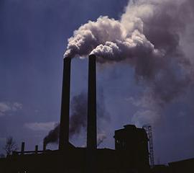Pollution is the degradation of natural environment by external substances introduced directly or indirectly. Human health, ecosystem quality and aquatic and terrestrial biodiversity may be affected and altered permanently by pollution.

Pollution occurs when ecosystems can not get rid of substances introduced into the environment. The critical threshold of its ability to naturally eliminate substances is compromised and the balance of the ecosystem is broken.

The sources of pollution are numerous. The identification of these different pollutants and their effects on ecosystems is complex. They can come from natural disasters or the result of human activity, such as oil spills, chemical spills, nuclear accidents ... These can have terrible consequences on people and the planet where they live: destruction of the biodiversity, increased mortality of the human and animal species, destruction of natural habitat, damage caused to the quality of soil, water and air ...

Preventing pollution and protecting the environment necessitate the application of the principles of sustainable development. we have to consider to satisfy the needs of today without compromising the ability of future generations to meet their needs. This means that we should remedy existing pollution, but also anticipate and prevent future pollution sources in order to protect the environment and public health. Any environmental damage must be punishable by law, and polluters should pay compensation for the damage caused to the environment.

1. The damage caused by pollution might be irreversible:  
   a.  True  
   b.  False
2. The ecosystem  
   a.  can always cope with pollutants  
   b.  may not always be able to cope with pollution.
3. Pollution  
   a.  is always caused by humans.  
   b.  may sometimes be caused by natural disasters.
4. An ideal solution to prevent pollution would be to  
   a.  refrain the development of some countries.  
   b.  continue developmental projects.  
   c .  take into consideration the future generations need to live in a healthy environment.

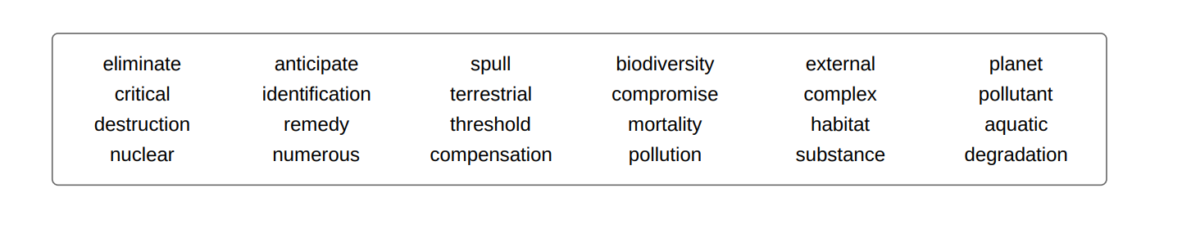

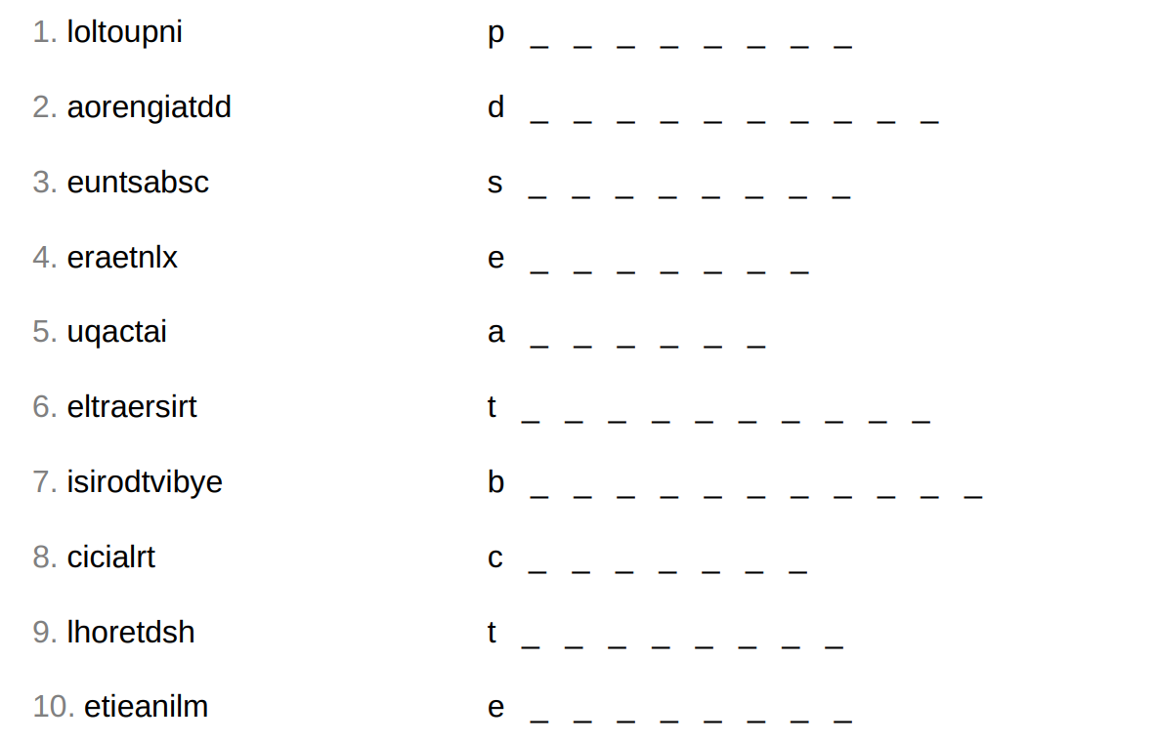

|  |  |  |
| --- | --- | --- |
| 单词：词性 | 文中释义 | 文中搭配 |
|  |  |  |
|  |  |  |
|  |  |  |
|  |  |  |
|  |  |  |
|  |  |  |
|  |  |  |
|  |  |  |
|  |  |  |
|  |  |  |
|  |  |  |
|  |  |  |
|  |  |  |
|  |  |  |
|  |  |  |
|  |  |  |
|  |  |  |
|  |  |  |
|  |  |  |
|  |  |  |
|  |  |  |



### What is meditation?

The term **meditation** refers to a practice where a person uses techniques, such as mindfulness, or focusing their mind on a particular object, thought, or activity. Meditation aims at training the attention and awareness and achieving a mentally clear and emotionally calm and stable state.

Meditation has been practiced since antiquity in numerous religious traditions and beliefs, often as part of the path towards enlightenment and self-realization. Since the 19th century, it has spread from its origins to other cultures where it is commonly practiced in private and business life.

### How do you meditate?

Most meditation techniques don't require specialized equipment or space. Generally, these techniques can be classified into two broad categories:

1. Focused (or concentrative) meditation:  
   This involves the voluntary focusing of attention on a chosen object, breathing, image, or words.
2. Open monitoring (or mindfulness) meditation:  
   This involves the focus on all mental events that enter the field of awareness.

Generally speaking, beginners should start with short periods of meditation (e.g. three minutes) that involves four steps:

1. Finding a comfortable position.
2. Closing one's eyes.
3. Breathing naturally.
4. Focusing the attention on the breath.

While meditating, the individual has to be aware of the body's reactions to every inhalation and exhalation. That is, as one breathes attention should be brought to the movement of your body mainly the chest, the belly, and the shoulders.

### What are the benefits of meditation?

Meditation is an old practice that aims at training the mind and the body to relax and get calm. It is known for improving psychological balance, dealing with illness, and enhancing general health and well-being. Some of the [benefits of meditation](https://www.healthline.com/nutrition/12-benefits-of-meditation" \t "https://www.myenglishpages.com/english/_blank) identified by experts include:

* Stress reduction.
* Anxiety control.
* Emotional health promotion.
* Self-Awareness enhancement.
* Attention span lengthening.
* 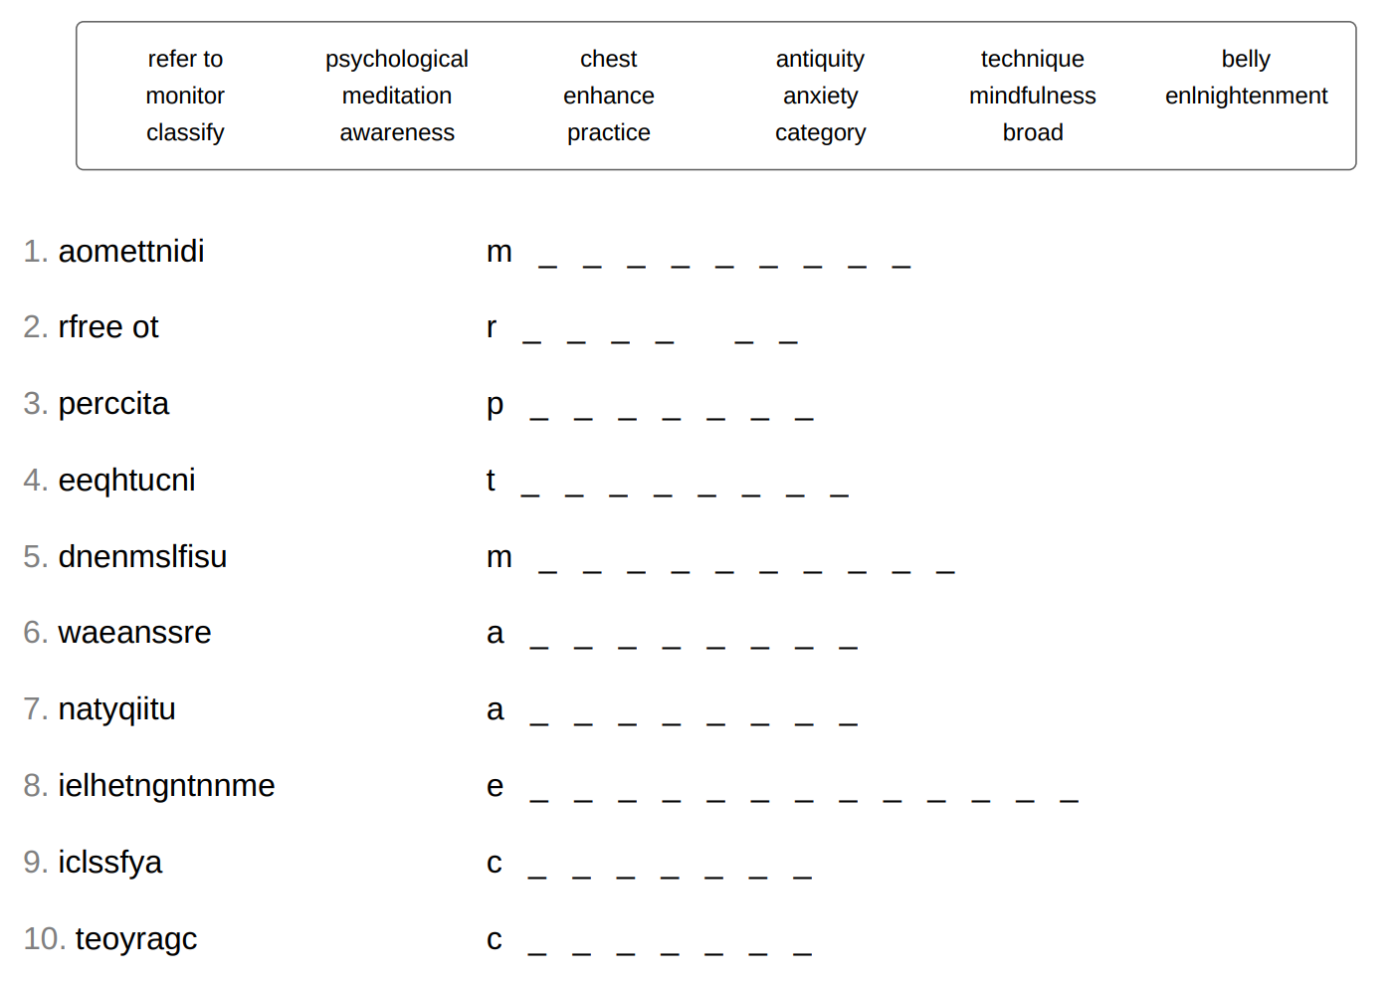Age-related memory loss reduction.
* Kindness generation.
* Addiction treatment.
* Sleep improvement
* Pain control
* Blood pressure decrease.

|  |  |  |
| --- | --- | --- |
| 单词：词性 | 文中释义 | 文中搭配 |
|  |  |  |
|  |  |  |
|  |  |  |
|  |  |  |
|  |  |  |
|  |  |  |
|  |  |  |
|  |  |  |
|  |  |  |
|  |  |  |
|  |  |  |
|  |  |  |
|  |  |  |
|  |  |  |
|  |  |  |
|  |  |  |
|  |  |  |
|  |  |  |
|  |  |  |
|  |  |  |
|  |  |  |
|  |  |  |
|  |  |  |



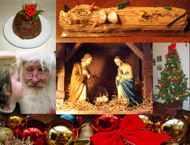

### Christmas

Christmas which is celebrated on December 25th is an important Christian holiday. The origin of the word "Christmas" comes from "Christ" and the "Holy.Mass" . It is believed that the day commemorates the birth of Jesus Christ although a lot of people doubt that the Day corresponds to the actual date of his birth. In spite of its Christian origin, Christmas is also celebrated by a lot of non Christian countries and the celebration includes a lot of non religious customs. People exchange gifts and greeting cards. Homes are decorated with Christmas trees, light and garlands. Dinners are planned with special food and all the families gather to have a lot of fun.

A central imaginary figure in Christmas is Father Christmas, also called Santa Claus. He is believed to fly on his sleigh bringing gifts for children .

Christmas is also an opportunity for economic growth. It has become an important period for business activity. Shops make a lot of profit and a lot of countries realized this economic impact.

### What Does Christmas Mean Today?

Today, Christmas is still connected to its religious background although it has gained some secular characteristics. For many people, Christmas is spending extra time with family, expressing thanks and love, sharing and making others happy, and commemorating the birth of the central figure of Christianity, Jesus Christ.

Christmas is also a worldwide cultural and economic phenomenon. It is considered the most significant economic boost for many countries worldwide since sales in practically all retail categories surge considerably. People buy and exchange gifts, decorate Christmas trees, enjoy meals with family and friends, and, of course, wait for Santa Claus to arrive.

1. Christmas celebration is on  
   a.  December 24,  
   b.  December 25,  
   c.  December 26.
2. Jesus Christ's Date of birth  
   a.  is on December 25th.  
   b.  We are not sure about the exact date.
3. Santa Claus comes  
   a.  on foot  
   b.  on a flying sleigh

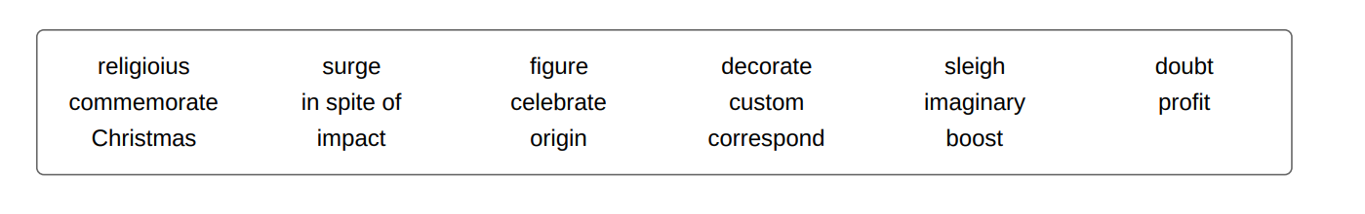

|  |  |  |
| --- | --- | --- |
| 单词：词性 | 文中释义 | 文中搭配 |
|  |  |  |
|  |  |  |
|  |  |  |
|  |  |  |
|  |  |  |
|  |  |  |
|  |  |  |
|  |  |  |
|  |  |  |
|  |  |  |
|  |  |  |
|  |  |  |
|  |  |  |
|  |  |  |
|  |  |  |
|  |  |  |
|  |  |  |
|  |  |  |
|  |  |  |
|  |  |  |
|  |  |  |
|  |  |  |
|  |  |  |



****Computer addiction**** can be defined as the excessive or compulsive use of the computer which persists despite serious negative consequences for personal, social, or occupational function. The addiction involves online and/or offline computer usage and consists of at least three subtypes: excessive gaming, sexual preoccupations, and e-mail/text messaging".

#### **Offline and online computer addiction**

The concept of computer addiction is broadly divided into two types, namely offline and online computer addiction. The term offline computer addiction is generally used when speaking about excessive gaming behavior, which can be practiced both offline and online. Online computer addiction, also known as Internet addiction, gets more attention in general from scientific research than offline computer addiction, mainly because most cases of computer addiction are related to the excessive use of the Internet.

#### **Symptoms**

The symptoms of computer addiction include

* Being drawn by the computer as soon as one wakes up and before one goes to bed.
* Replacing old hobbies with excessive use of the computer and using the computer as one's primary source of entertainment and procrastination
* Lacking physical exercise and/or outdoor exposure because of constant use of the computer. This could contribute to many health problems such as obesity

#### **Causes and effects**

Researchers link internet/computer addiction with existing mental health issues, most notably depression. Studies showed that the majority of those who met the requirements of internet/computer addiction suffered from interpersonal difficulties and stress and that those addicted to online games specifically responded that they hoped to avoid reality.

There are many consequences resulting from computer addiction. For example, excessive computer use may result in lack of face to face social interaction. It may also lead to Computer Vision Syndrome (CVS), a condition that results in headaches, blurred vision, neck pain, fatigue, eye strain, dry eyes, irritated eyes, double vision, vertigo or dizziness.

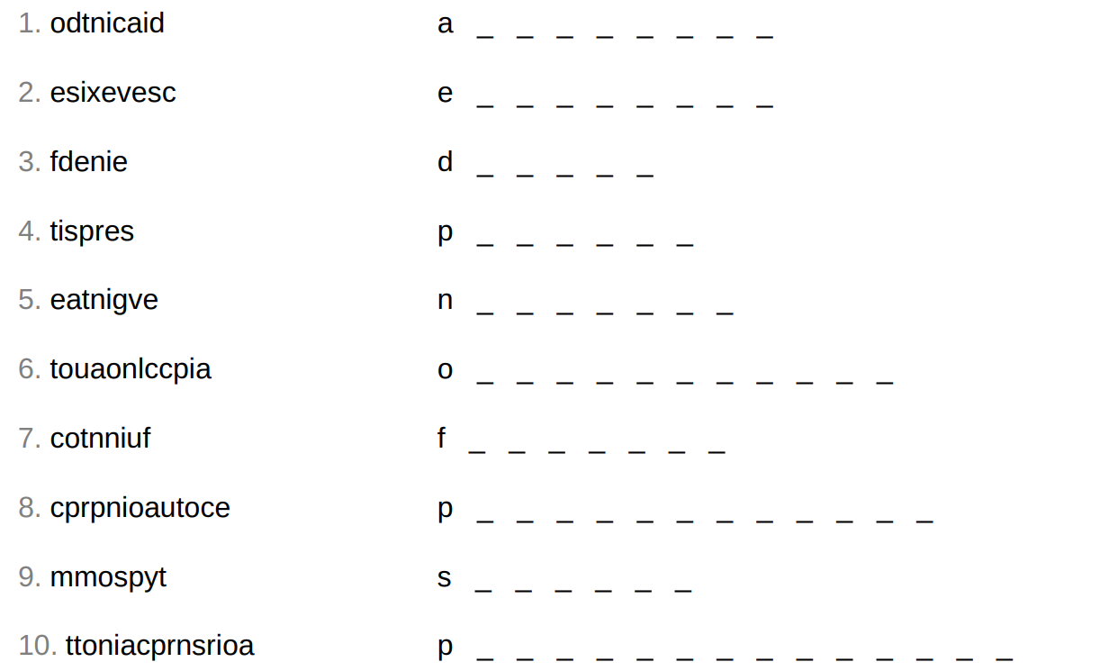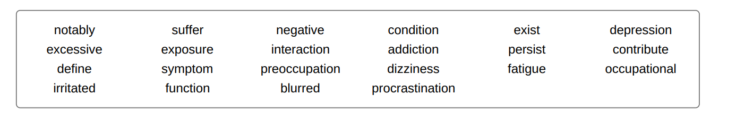

|  |  |  |
| --- | --- | --- |
| 单词：词性 | 文中释义 | 文中搭配 |
|  |  |  |
|  |  |  |
|  |  |  |
|  |  |  |
|  |  |  |
|  |  |  |
|  |  |  |
|  |  |  |
|  |  |  |
|  |  |  |
|  |  |  |
|  |  |  |
|  |  |  |
|  |  |  |
|  |  |  |
|  |  |  |
|  |  |  |
|  |  |  |
|  |  |  |
|  |  |  |
|  |  |  |
|  |  |  |
|  |  |  |



#### IMG_256What is culture shock?

Culture shock refers to the feeling of disorientation experienced by people when they move to an unfamiliar cultural environment or when they are suddenly exposed to a different way of life or set of attitudes. This can be the result of immigration or a visit to a new country, a move between social environments, or simply a transition to another type of life.

#### Culture shock stages

Culture shock consists of four distinct stages: honeymoon, negotiation, adjustment, and adaptation. The honeymoon stage occurs when the individual sees the differences between the old and new culture in a romantic light. In the negotiation stage, the differences between the old and new culture become apparent and may create anxiety. The adjustment stage refers to the period when the individual grows accustomed to the new culture and develops routines. Finally, in the adaptation stage, individuals are able to participate fully and comfortably in the host culture. Adaptation or acceptance does not mean total conversion; people often keep many traits from their earlier culture, such as accents and languages. It is often referred to as the bicultural stage.

#### Homesickness

Culture shock may cause homesickness. This refers to the feeling of longing for one's home. People suffering from culture shock typically experience a combination of depressive and anxious symptoms related to homesickness. Ways of coping with homesickness include developing a hobby, thinking positively and feeling grateful about what one has, and building new relationships.

Cultural shock is a natural phenomenon that occurs when one has a cross-cultural experience. Going through the different stages can take weeks, months or years. But ultimately, the experience can be enriching and may end up with either adaptation with the new culture or a return home.

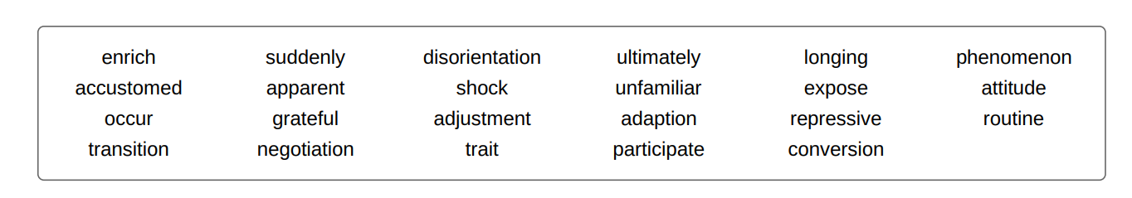

1. Culture shock occurs only as a result of immigration.  
   a.  True  
   b.  False
2. The adaptation stage means that there is a complete change of personality.  
   a.  True  
   b.  False
3. Homesickness and culture shock refer to the same thing.  
   a.  True  
   b.  False
4. Culture shock has also positive effects on people experiencing it.  
   a.  True  
   b.  False.

|  |  |  |
| --- | --- | --- |
| 单词：词性 | 文中释义 | 文中搭配 |
|  |  |  |
|  |  |  |
|  |  |  |
|  |  |  |
|  |  |  |
|  |  |  |
|  |  |  |
|  |  |  |
|  |  |  |
|  |  |  |
|  |  |  |
|  |  |  |
|  |  |  |
|  |  |  |
|  |  |  |
|  |  |  |
|  |  |  |
|  |  |  |
|  |  |  |
|  |  |  |
|  |  |  |
|  |  |  |
|  |  |  |





The Winter Olympic Games is a major international sporting event that occurs once every four years. The first Winter Olympics, the 1924 Winter Olympics, was held in Chamonix, France. The original [sports](https://www.myenglishpages.com/english/vocabulary-lesson-olympic-winter-games.php) were alpine and cross-country skiing, figure skating, ice hockey, Nordic combined, ski jumping and speed skating.

The Games were held every four years from 1924 until 1936, after which they were interrupted by World War II. The Olympics resumed in 1948 and was again held every four years. Until 1992, the Winter and Summer Olympic Games were held in the same years, but in accordance with a 1986 decision by the International Olympic Committee (IOC) to place the Summer and Winter Games on separate four-year cycles in alternating even-numbered years, the next Winter Olympics after 1992 was in 1994.

The Winter Olympics has been hosted on three continents by eleven different countries, but never in a country in the southern hemisphere.

1. The games are held every four years.  
   a.  True  
   b.  False
2. Winter Olympics and Summer Olympic games have always been held in the same year.  
   a.  True.  
   b.  False.
3. Winter Olympics have never been held in south America.  
   a.  True  
   b.  False

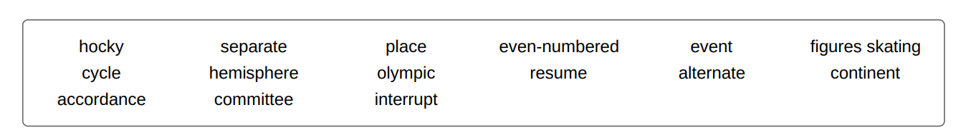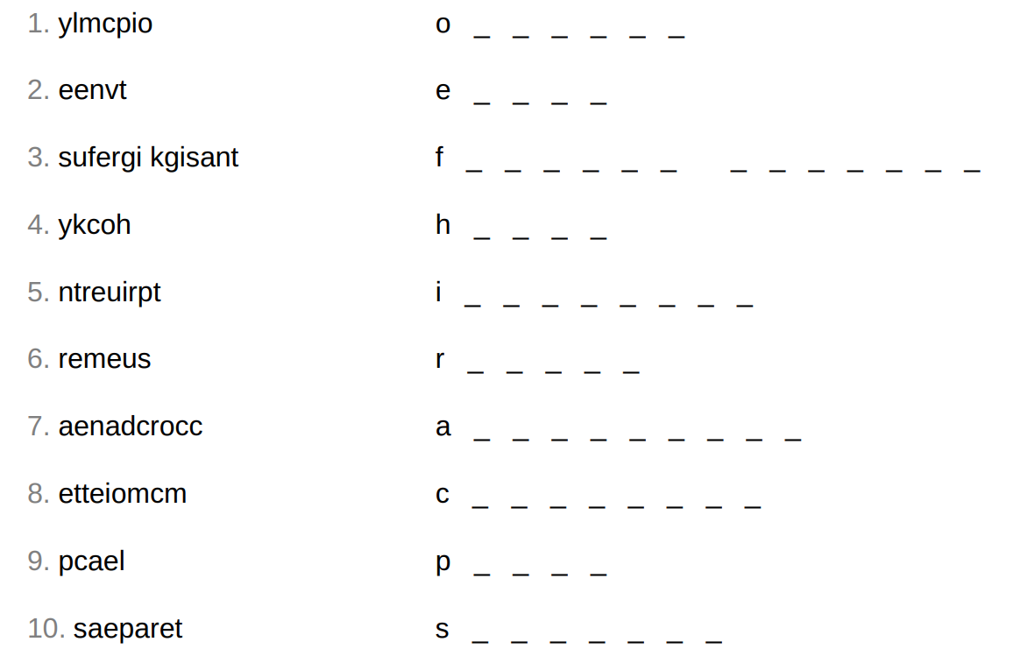

|  |  |  |
| --- | --- | --- |
| 单词：词性 | 文中释义 | 文中搭配 |
|  |  |  |
|  |  |  |
|  |  |  |
|  |  |  |
|  |  |  |
|  |  |  |
|  |  |  |
|  |  |  |
|  |  |  |
|  |  |  |
|  |  |  |
|  |  |  |
|  |  |  |
|  |  |  |
|  |  |  |
|  |  |  |
|  |  |  |
|  |  |  |
|  |  |  |
|  |  |  |
|  |  |  |
|  |  |  |
|  |  |  |



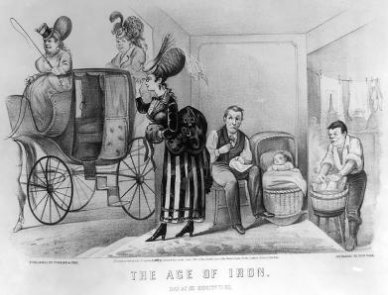

### Stereotypes

A ****stereotype**** is a fixed idea that people have about what specific social groups or individuals are like, especially an idea that is wrong. Other terms that are associated with the term stereotype are prejudice and cliché. The term has a Greek origin: stereos means solid or firm and typos mean blow, impression, engraved or mark. The term was first used in the printing business. The first modern English use of the term was in 1850, meaning "image perpetuated without change."

Because stereotypes are standardized and simplified ideas of groups, based on some prejudices, they are not derived from objective facts, but rather subjective and often unverifiable ideas. As Sociologist Charles E. Hurst states\* "One reason for stereotypes is the lack of personal, concrete familiarity that individuals have with persons in other racial or ethnic groups. Lack of familiarity encourages the lumping together of unknown individuals".

The existence of stereotypes may be explained by the need of groups of people to view themselves as more normal or more superior than other groups. Consequently, stereotypes may be used to justify ill-founded prejudices or ignorance and prevent people of stereotyped groups from entering or succeeding in various activities or fields. The stereotyping group are, generally, reluctant to reconsider their attitudes and behavior towards stereotyped group.

Stereotypes may affect people negatively. This includes forming inaccurate and distorted images and opinions of people. Stereotypes may also be used for scapegoating or for making general erroneous judgments about people. Some stereotyping people may feel comfortable when they prevent themselves from emotional identification with the stereotyped group, which leads to xenophobic or racist behavior. Finally another serious consequence of stereotypes is the feeling of inferiority that the stereotyped people may have and which may impair their performance.

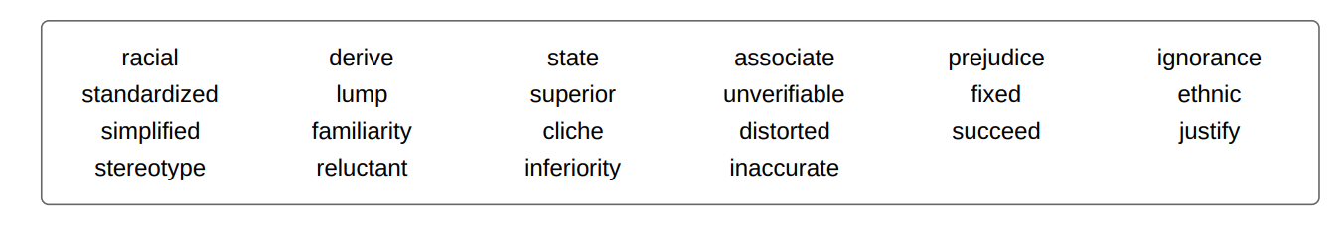

1. The word stereotype has:  
   a.  a Greek origin.  
   b.  an English origin.
2. Stereotypes are used to:  
   a.  make generalizations about different groups of people.  
   b.  have an accurate understanding of the stereotyped people.
3. If you label people in terms of stereotypes, you will probably :  
   a.  be having an exact judgment of their worth.  
   b.  be behaving in a discriminatory way

|  |  |  |
| --- | --- | --- |
| 单词：词性 | 文中释义 | 文中搭配 |
|  |  |  |
|  |  |  |
|  |  |  |
|  |  |  |
|  |  |  |
|  |  |  |
|  |  |  |
|  |  |  |
|  |  |  |
|  |  |  |
|  |  |  |
|  |  |  |
|  |  |  |
|  |  |  |
|  |  |  |
|  |  |  |
|  |  |  |
|  |  |  |
|  |  |  |
|  |  |  |
|  |  |  |
|  |  |  |
|  |  |  |



### IMG_256Women's Rights

Feminism is the belief and aim that women should have the same rights, power, and opportunities as men.

Women won their present status through struggle and sacrifices rather than through men's kindness. Women and their supporters have fought and in some places continue to fight for the same rights as men. Laws were made to replace local customs which denigrated and suppressed women's rights. Women have gained higher positions in the world at all levels: political, economic and social.

Historically, whether in Hindu, Greek or Roman civilizations women were always minors and subject to men. It was only during the Islamic civilization, between 610 and 661, that the early reforms were undertaken. The reforms gave women greater rights than Muslim women in pre-Islamic Arabia and medieval Europe.These reforms included greater rights in marriage, divorce and inheritance. Women were not accorded with such legal status in other cultures until centuries later.

During the middle ages women were enslaved and were denied all rights in Europe. In the late 18th century, however, women's status became a subject of political debate. In the 19th century women started their fight for equal rights. In the late 19th century they won the right to vote (suffrage) in various countries in the world. More gigantic steps were taken during the following years. Women gained more economic, social and political status in various degrees and in different countries.

In Spite of all the success women still suffer from discrimination at various levels. For example women work more and earn less than men. In addition to that, the majority of the world's poor and illiterate are women. The road to real equality is still long.

1. The first reforms occurred in Europe.  
   a.  True  
   b.  False
2. Political debate over women's status started in the 18th century.  
   a.  True  
   b.  False.
3. Women gained the right to vote during the 19th century.  
   a.  True  
   b.  False.

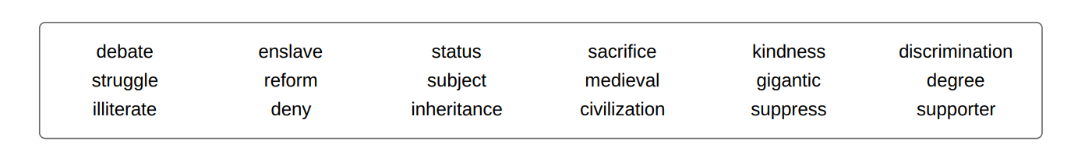

|  |  |  |
| --- | --- | --- |
| 单词：词性 | 文中释义 | 文中搭配 |
|  |  |  |
|  |  |  |
|  |  |  |
|  |  |  |
|  |  |  |
|  |  |  |
|  |  |  |
|  |  |  |
|  |  |  |
|  |  |  |
|  |  |  |
|  |  |  |
|  |  |  |
|  |  |  |
|  |  |  |
|  |  |  |
|  |  |  |
|  |  |  |
|  |  |  |
|  |  |  |
|  |  |  |
|  |  |  |
|  |  |  |





## The World Wide Web

The ****World Wide Web, the WWW**** or ****the Web**** refers to an information space w

here documents and other web resources are identified by Uniform Resource Locators (URLs), interlinked by hypertext links, and can be accessed via the Internet. It was invented by the English scientist Tim Berners-Lee in 1989. He wrote the first web browser computer program in 1990. The World Wide Web has been central to the development of the Information Age and is the primary tool billions of people use to interact on the Internet.

Web pages are primarily text documents formatted and annotated with Hypertext Markup Language (HTML). In addition to formatted text, web pages may contain images, video, audio, and software components that are rendered in the user's web browser as coherent pages of multimedia content. Embedded hyperlinks permit users to navigate between web pages. Multiple web pages with a common domain name make up a website. Website content can largely be provided by the publisher or by users who contribute content online.

Recently, many people have criticized today's misuse of the web. The inventor of the World Wide Web, Tim Berners-Lee himself has warned of the dangers of the Internet. According to him, the web has become a tool in the hand of the powerful to get what they want. For example, he warns that fake news is disseminated either to generate a lot of money or to attempt to manipulate people's opinions . Another worry was the gross invasion of privacy. Tim Berners-Lee is also concerned about governments' misuse of the Internet to collect personal data to manipulate or oppress people.

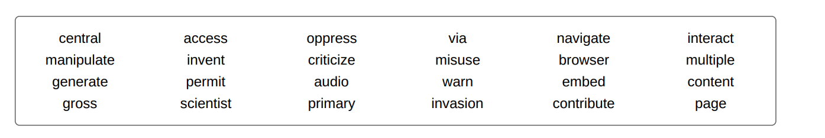

1. The World Wide Web was invented by Tim Berners-Lee in 1990.  
   a.  True  
   b.  False
2. Web users can supply content to websites.  
   a.  True.  
   b.  False.
3. Although the World Wide Web has contributed to the development of the Information Age, many people look at it with a critical eye.  
   a.  True  
   b.  False

|  |  |  |
| --- | --- | --- |
| 单词：词性 | 文中释义 | 文中搭配 |
|  |  |  |
|  |  |  |
|  |  |  |
|  |  |  |
|  |  |  |
|  |  |  |
|  |  |  |
|  |  |  |
|  |  |  |
|  |  |  |
|  |  |  |
|  |  |  |
|  |  |  |
|  |  |  |
|  |  |  |
|  |  |  |
|  |  |  |
|  |  |  |
|  |  |  |
|  |  |  |
|  |  |  |
|  |  |  |
|  |  |  |



### What is friendship in simple words?

Friendship is defined as a bond of affection between two people. People are referred to as best friends if the friendship is really strong. this relationship is characterized by positive interpersonal qualities such as kindness, generosity, loyalty, and honesty. True friends choose to be with one another, enjoy time spent together, and can engage in a positive and supportive role to one another.

### What are the different types of friends?

### Aquaintances

It's easy to classify acquaintances. They're the people you meet frequently at casual places but don't truly know each other. These are people we know well enough to strike up a conversation with from time to time, but not people we'd ask to a dinner party or contact for help.

#### Close friends

You're more inclined to seek help or support from a close buddy. There is not only a high level of trust amongst close friends but also a great deal of genuine love and affection. Even if you disagree with a close friend's decisions, you would protect his or her freedom to make them.

#### Best friends

Although best friends are quite rare, they are people whom we need in our lives. Your best friend understands you without much explanation and is always there for you. Your relationship with your best friend is not dependent on the time you spend together. You may not meet your best friends for a long time. But once you get in touch with them, you feel as if nothing has changed in your friendship. These connections are distinct in their ability to adapt to the environment and endure despite the vagaries of life.

#### Virtual friends

[Virtual friendship](https://link.springer.com/article/10.1007/s10676-011-9284-4" \t "_blank) is a relatively new type of friendship. It refers to friendship that takes place on the internet and is unlikely to be connected to real-life interaction. It is contrasted with the traditional friendships that we have listed above. The latter is a form of relationship that requires a lot of face-to-face connection.

This type of friendship developed as a result of advances in technology. The internet, especially social media, played an undeniable role in connecting people worldwide.

1. There are different levels of friendship.  
   a.  True  
   b.  False
2. Best friends are necessarily people we always meet.  
   a.  True  
   b.  False
3. Virtual friendship is an old type of relationships.  
   a.  True  
   b.  False

|  |  |  |
| --- | --- | --- |
| 单词：词性 | 文中释义 | 文中搭配 |
|  |  |  |
|  |  |  |
|  |  |  |
|  |  |  |
|  |  |  |
|  |  |  |
|  |  |  |
|  |  |  |
|  |  |  |
|  |  |  |
|  |  |  |
|  |  |  |
|  |  |  |
|  |  |  |
|  |  |  |
|  |  |  |
|  |  |  |
|  |  |  |
|  |  |  |
|  |  |  |
|  |  |  |
|  |  |  |
|  |  |  |

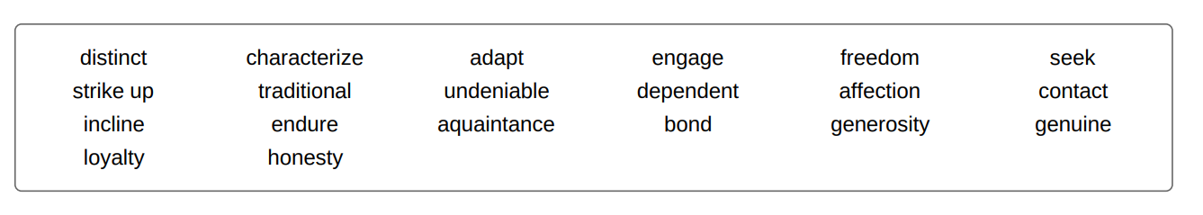



## The Fourth of July

****Independence Day****, also referred to as ****the Fourth of July**** or ****July 4****, is an American federal holiday commemorating the Declaration of Independence of the United States, on July 4, 1776. The Continental Congress declared that the thirteen American colonies were no longer under the rule of the monarch of Britain, King George III, and were now united, free, and independent states.

## Celebrations

****Independence Day is the national day of the United States and is associated with many activities. Public and private events celebrating the history, government, and traditions of the United States are organized. It is also generally associated with fireworks, family gatherings, carnivals, fairs, picnics, and concerts.****

## 9 Interesting facts about Independence Day

Here are 9 interesting facts about Independence Day:

1. Congress had voted for the declaration of independence on July 2, but it was not declared until July 4.
2. On June 11, 1776, Congress appointed a "Committee of Five", consisting of John Adams, Benjamin Franklin, Thomas Jefferson, Robert R. Livingston, and Roger Sherman, to draft the declaration. Jefferson wrote the first draft which was then edited by the others and then edited again by the whole Congress.
3. Fifty-six members of Congress signed the declaration.
4. By a striking coincidence, Thomas Jefferson and John Adams, the only two signatories of the Declaration of Independence later to serve as presidents of the United States, died on the same day: July 4, 1826, which was the 50th anniversary of the Declaration.
5. Although not a signatory of the Declaration of Independence, James Monroe, another Founding Father who was elected as president, also died on July 4, 1831, making him the third President who died on the anniversary of independence.
6. The only U.S. president to have been born on Independence Day was Calvin Coolidge, who was born on July 4, 1872
7. Almost 100 years after the Declaration of Independence, in 1870, July 4 was made an official holiday by Congress.
8. Every 4th of July, the Liberty Bell in Philadelphia is tapped thirteen times in honor of the original 13 American colonies.
9. Fireworks are an important part of the holiday because the first Independence Day celebration on July 4, 1777, witnessed Americans meeting to watch as the sky illuminated to commemorate the new nation.

|  |  |  |
| --- | --- | --- |
| 单词：词性 | 文中释义 | 文中搭配 |
|  |  |  |
|  |  |  |
|  |  |  |
|  |  |  |
|  |  |  |
|  |  |  |
|  |  |  |
|  |  |  |
|  |  |  |
|  |  |  |
|  |  |  |
|  |  |  |
|  |  |  |
|  |  |  |
|  |  |  |
|  |  |  |
|  |  |  |
|  |  |  |
|  |  |  |
|  |  |  |
|  |  |  |
|  |  |  |
|  |  |  |



### Why do people change their careers?

1. The downsizing or the restructuring of an organization (54%).
2. New challenges or opportunities that arise (30%).
3. Poor or ineffective leadership (25%).
4. Having a poor relationship with a manager(s) (22%).
5. For the improvement of a better work/life balance (21%).
6. Contributions are not being recognized (21%).
7. For better compensation and benefits (18%),
8. For better alignment with personal and organizational values (17%).
9. Personal strengths and capabilities are not a good fit with an organization (16%).
10. The financial instability of an organization (13%).
11. An organization relocated (12%).

Because the world has become so competitive, you will have to do your best to secure your share of success. The following are tips to get you ahead in your career.

1. Priorities and goals

What are your priorities of the day? Make a list and of your priorities and plan your day. The tasks of the day must be outlined with the most important and urgent ones on top.

Likewise determine your short-term and long-term goals and evaluate your progress frequently.

2. Be focused

Are you really present physically and mentally. Try to block out all distractions so that you have the time to truly focus on your tasks and career.

3. Broaden your skills

Nothing remains the same and so do job requirements. Update your knowledge and skills. Seek improvement of your know-hows. Attend seminars, conferences, read books, be an eternal learner.

4. Socialize

Be ready to participate in social functions. Be open to new acquaintances. Meet new people and deal with them respectfully and enthusiastically. Be an active listener; you will surely learn something new...

5. Know your merits

Know your strengths and weaknesses. If you think you deserve a position or promotion, claim it.

6. Accept challenge

Through challenge you will reach areas of your personality you have never discovered before. It is a good idea to step away from your comfort zone to explore new horizons. If you settle into a routine and play it safe all the time, you will never get ahead in your career. 'If you always do what you've always done, you'll only get what you've already got'

7. Communication

Learn to communicate effectively. Listen to what others are saying and focus on how to give and receive constructive feedback, to persuade effectively and to ask for help and collect information.

8. Avoid gossip

Avoid office gossip about colleagues and the boss. Be respectful and work for the good of the company.

9 Relax

Relax and do something different, a hobby that you love doing. Take time off for yourself. This will help boost your productivity during week days.

10. Seek satisfaction

If you are disappointed with what you are doing, try to transform it into something you love. If you fail, it might be a good idea to do something different. As Confucius said: 'Choose a job you love, and you will never have to work a day in your life. '

|  |  |  |
| --- | --- | --- |
| 单词：词性 | 文中释义 | 文中搭配 |
|  |  |  |
|  |  |  |
|  |  |  |
|  |  |  |
|  |  |  |
|  |  |  |
|  |  |  |
|  |  |  |
|  |  |  |
|  |  |  |
|  |  |  |
|  |  |  |
|  |  |  |
|  |  |  |
|  |  |  |
|  |  |  |
|  |  |  |
|  |  |  |
|  |  |  |
|  |  |  |
|  |  |  |
|  |  |  |
|  |  |  |



### What does cloud computing mean?

Cloud computing means storing and accessing data and programs over the Internet instead of your computer's hard drive. It involves computing over a network, where a program or application may run on many connected computers at the same time.

For some, cloud computing is a metaphor for the Internet. It typically uses connected hardware machines called servers. Individual users can use the server's processing power to run an application, store data, or perform any other computing task. Thus, instead of using a personal computer every-time to run the application, the individual can now run the application from anywhere in the world.

For businesses, cloud computing is an ideal way to reduce expenses. For example, companies may buy services in the cloud. That is to say, instead of installing applications on every single computer in the company, cloud computing would allow workers to log into a Web-based service (a cloud) which hosts all the programs individual users would need for their job. Everything would run on remote machines and local computers task would rely just on connecting to those machines.

While cloud computing, could change the entire computer industry, there are still some concerns about the security of the data stored on the remote machines. It is true that it promises to offload many tasks. However, this technology raises a fundamental question. Is it safe to store one's data on someone else's computer? The cloud service provider needs to establish clear and relevant policies that describe how the data of each cloud user will be accessed and used. Cloud service users should also be able to encrypt data that is processed or stored within the cloud to prevent unauthorized access.

1. In cloud computing data is stored locally.  
   a.  True  
   b.  False
2. Cloud computing offers an economical model for businesses.  
   a.  True  
   b.  False
3. Cloud computing technology add workload on local machines.  
   a.  True  
   b.  False
4. This technology offers a perfect solution for businesses without any concerns.  
   a.  True  
   b.  False

|  |  |  |
| --- | --- | --- |
| 单词：词性 | 文中释义 | 文中搭配 |
|  |  |  |
|  |  |  |
|  |  |  |
|  |  |  |
|  |  |  |
|  |  |  |
|  |  |  |
|  |  |  |
|  |  |  |
|  |  |  |
|  |  |  |
|  |  |  |
|  |  |  |
|  |  |  |
|  |  |  |
|  |  |  |
|  |  |  |
|  |  |  |
|  |  |  |
|  |  |  |
|  |  |  |
|  |  |  |
|  |  |  |



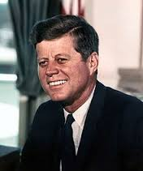

JFK

John Fitzgerald Kennedy, born on May 29, 1917, was the 35th President of the United States, serving from January 1961 until he was assassinated in November 1963.

At the age of 43, he was the youngest to have been elected to the office, the second-youngest president (after Theodore Roosevelt), the first person born in the 20th century to serve as president. To date, Kennedy has been the only Catholic president and the only president to have won a Pulitzer Prize.

Events during his presidency included the Bay of Pigs Invasion, the Cuban Missile Crisis, the Space Race - by initiating Project Apollo (which would culminate in the moon landing), the building of the Berlin Wall, the African-American Civil Rights Movement, and increased U.S. involvement in the Vietnam War.

Kennedy was assassinated on November 22, 1963, in Dallas, Texas. Lee Harvey Oswald was accused of the crime and arrested that evening, but Jack Ruby shot and killed him two days later, before a trial could take place. The FBI and the Warren Commission officially concluded that Oswald was the lone assassin. However, the United States House Select Committee on Assassinations (HSCA) concluded that those investigations were flawed and that Kennedy was probably assassinated as the result of a conspiracy.

Since the 1960s, information concerning Kennedy's private life has come to light. Details of Kennedy's health problems with which he struggled have become better known, especially since the 1990s. Although initially kept secret from the general public, reports of Kennedy being unfaithful in marriage have garnered much press. Kennedy ranks highly in public opinion ratings of U.S. presidents.

1. John Kennedy served two mandates  
   a.  True  
   b.  False
2. He never served as an army officer.  
   a.  True  
   b.  False
3. The reason behind John Kennedy's murder is still unclear.  
   a.  True  
   b.  False
4. News about his health problems has been known since his death  
   a.  True  
   b.  False

|  |  |  |
| --- | --- | --- |
| 单词：词性 | 文中释义 | 文中搭配 |
|  |  |  |
|  |  |  |
|  |  |  |
|  |  |  |
|  |  |  |
|  |  |  |
|  |  |  |
|  |  |  |
|  |  |  |
|  |  |  |
|  |  |  |
|  |  |  |
|  |  |  |
|  |  |  |
|  |  |  |
|  |  |  |
|  |  |  |
|  |  |  |
|  |  |  |
|  |  |  |
|  |  |  |
|  |  |  |
|  |  |  |



#### IMG_256A big mystery: the tremendous benefits of laughter.

Humor, the tendency of particular cognitive experiences to provoke laughter and provide amusement, affects how we perceive and respond to life. It enhances the quality of life and may relieve the body from so many health problems. In fact, humans are the only creatures on earth that are endowed with the ability to laugh.

The difference between humor and laughter is that humor is a perceptual process while laughter is a behavioral response. People of all ages and cultures respond to humor. The majority of people are able to experience humor, i.e., to be amused, to laugh or smile at something funny, and thus they are considered to have a ****sense of humor****. The hypothetical person lacking a sense of humor would likely find the behavior induced by humor to be inexplicable, strange, or even irrational. Though ultimately decided by personal taste, the extent to which a person will find something humorous depends upon a host of variables, including geographical location, culture, maturity, level of education, intelligence and context.

Regular laughter sessions can have important effects on our health and well being. For instance, laughter is considered to be a stress buster and researchers found a direct link between laughter and healthy function of blood vessels. Laughter causes the dilatation of the inner lining of blood vessels, the endothelium, and increases blood flow. It also has been shown to lead to reductions in stress hormones such as cortisol and epinephrine. When laughing the brain also releases endorphins that can relieve some physical pain. Laughter also boosts the number of antibody-producing cells and enhances the effectiveness of T-cells, a type of cells that lead to a stronger immune system.

Since laughter does effect the body, mind and spirit the only thing you have to do to lead a happy life is LAUGH, as simple as that.

1. The expression "stress buster" means:  
   a.  something that stops stress,  
   b.  something that produces stress.
2. Laughter strengthens:  
   a.  the immune system  
   b.  the muscles
3. The response to humor is the same everywhere in the world.  
   a.  True  
   b.  False
4. A person lacking the sense of humor may find it difficult to get along with other people.  
   a.  True  
   b.  False

|  |  |  |
| --- | --- | --- |
| 单词：词性 | 文中释义 | 文中搭配 |
|  |  |  |
|  |  |  |
|  |  |  |
|  |  |  |
|  |  |  |
|  |  |  |
|  |  |  |
|  |  |  |
|  |  |  |
|  |  |  |
|  |  |  |
|  |  |  |
|  |  |  |
|  |  |  |
|  |  |  |
|  |  |  |
|  |  |  |
|  |  |  |
|  |  |  |
|  |  |  |
|  |  |  |
|  |  |  |
|  |  |  |



### IMG_256Organizations - UN

The United Nations was founded in 1945 after World War II to replace the League of Nations. It is an international organization whose stated aims are facilitating cooperation in international law, international security, economic development, social progress, human rights, and achievement of world peace. The philosophy behind its establishment is to stop wars between countries, and to provide a platform for dialogue. The members of the UN consist of 193 member states, including every internationally recognized sovereign state in the world but Vatican City. The UN is headed by a Secretary-General.

The organization has six principal organs:

1. the General Assembly (the main deliberative assembly);
2. the Security Council (for deciding certain resolutions for peace and security);
3. the Economic and Social Council (for assisting in promoting international economic and social cooperation and development);
4. the Secretariat (for providing studies, information, and facilities needed by the UN);
5. the International Court of Justice (the primary judicial organ);
6. and the United Nations Trusteeship Council (which is currently inactive).

Other prominent UN System agencies include the [World Health Organization](https://www.myenglishpages.com/english/reading-organizations-world-health-organization.php) (WHO), the [World Food Programme](https://www.myenglishpages.com/english/reading-organizations-world-food-programme.php) (WFP) and United Nations Children's Fund ([UNICEF](https://www.myenglishpages.com/english/reading-organizations-unicef.php)).

The United Nations Headquarters resides in international territory in New York City, with further main offices at Geneva, Nairobi, and Vienna. The organization is financed from assessed and voluntary contributions from its member states, and has six official languages: Arabic, Chinese, English, French, Russian, and Spanish.

1. The UN was established during world war II.  
   a.  True  
   b.  False
2. The Vatican City is a member of the UN.  
   a.  True  
   b.  False
3. The UN contains multiple subsidiary organizations to carry out its missions.  
   a.  True  
   b.  False
4. The UN accepts contributions from its member states.  
   a.  True  
   b.  False

|  |  |  |
| --- | --- | --- |
| 单词：词性 | 文中释义 | 文中搭配 |
|  |  |  |
|  |  |  |
|  |  |  |
|  |  |  |
|  |  |  |
|  |  |  |
|  |  |  |
|  |  |  |
|  |  |  |
|  |  |  |
|  |  |  |
|  |  |  |
|  |  |  |
|  |  |  |
|  |  |  |
|  |  |  |
|  |  |  |
|  |  |  |
|  |  |  |
|  |  |  |
|  |  |  |
|  |  |  |
|  |  |  |



#### By Imperatom2 - Own work, CC0, https://commons.wikimedia.org/w/index.php?curid=22620329What is smoking?

Smoking is one of the most common forms of recreational drug use. It is a habit which consists of breathing in a smoke from a burned substance. This substance contains the active alkaloid nicotine which is absorbed into the bloodstream. It may cause various diseases and dysfunctions. Tobacco smoking is the most popular form of smoking. It is practiced by over one billion people globally, of whom the majority are in the developing world. Less common drugs for smoking include cannabis and opium. Some of the substances are classified as hard narcotics, like heroin, but the use of these substances is very limited as they are usually not commercially available.

#### History of smoking

The practice of smoking can be dated to as early as 5000 BC, and has been recorded in many different cultures across the world. Early smoking evolved in association with religious ceremonies; as offerings to deities, in cleansing rituals or to allow shamans and priests to alter their minds for various religious purposes. After the European exploration and conquest of the Americas, the practice of smoking tobacco quickly spread to the rest of the world.

#### Smoking and health problems

Smoking has negative health effects, because smoke inhalation inherently poses challenges to various physiologic processes such as respiration. Diseases related to tobacco smoking have been shown to kill approximately half of long term smokers when compared to average mortality rates faced by non-smokers. A 2007 report states that, each year, about 4.9 million people worldwide die as a result of smoking. It is among the leading causes of many diseases such as lung cancer, heart attacks, erectile dysfunction, and birth defects. The health hazards of smoking have caused many countries to institute high taxes on tobacco products, run ads to discourage use, limit ads that promote use, and provide help with quitting for those who do smoke

|  |  |  |
| --- | --- | --- |
| 单词：词性 | 文中释义 | 文中搭配 |
|  |  |  |
|  |  |  |
|  |  |  |
|  |  |  |
|  |  |  |
|  |  |  |
|  |  |  |
|  |  |  |
|  |  |  |
|  |  |  |
|  |  |  |
|  |  |  |
|  |  |  |
|  |  |  |
|  |  |  |
|  |  |  |
|  |  |  |
|  |  |  |
|  |  |  |
|  |  |  |
|  |  |  |
|  |  |  |
|  |  |  |



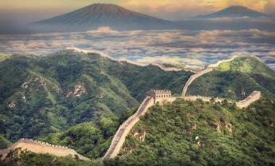

### The Great Wall Of China

The Great Wall of China, one of the greatest wonders of the world, was first built between 220–206 BC. In fact, it began as independent walls for different states when it was first built, and did not become the "Great" wall until the Qin Dynasty. Emperor Qin Shihuang succeeded in his effort to have the walls joined together to serve as fortification to protect the northern borders of the Chinese Empire from invasion. Afterwards it was rebuilt and maintained over the years, between the 5th century BC and the 16th century.

One of the myths associated with the Great Wall of China is that it is the only man-made structure that can be seen from the moon with the naked eye. The legend originated in Richard Halliburton's 1938 book Second Book of Marvels. However, This myth is simply not true. Richard Halliburton's claim was contradicted by astronauts Neil Armstrongby and Yang Liwei. A more plausible assumption would be to say that the Great Wall can be visible from a low orbit of the earth which is not unique in this regard as many other artificial constructions can be seen from that height.

1. The Great Wall of China was first built as a single wall.  
   a.  True  
   b.  False
2. The Great Wall of China  
   a.  was built in a single dynasty.  
   b.  was refurbished during its history.
3. The Great Wall was first designed  
   a.  to protect the Empire from invasion.  
   b.  to help trade between different provinces.
4. The wall can be seen from moon with the naked eye.  
   a.  True.  
   b.  False.

|  |  |  |
| --- | --- | --- |
| 单词：词性 | 文中释义 | 文中搭配 |
|  |  |  |
|  |  |  |
|  |  |  |
|  |  |  |
|  |  |  |
|  |  |  |
|  |  |  |
|  |  |  |
|  |  |  |
|  |  |  |
|  |  |  |
|  |  |  |
|  |  |  |
|  |  |  |
|  |  |  |
|  |  |  |
|  |  |  |
|  |  |  |
|  |  |  |
|  |  |  |
|  |  |  |
|  |  |  |
|  |  |  |



The British Victorian era was the period of Queen Victoria's reign from 20 June 1837 until her death, on 22 January 1901. It was a long period of peace, prosperity, "refined sensibilities" and national self-confidence for Britain.

**Prosperity**

Historians have characterized the mid-Victorian era, (1850–1870) as Britain's 'Golden Years.' There was prosperity, as the national income per person grew by half. Much of the prosperity was due to the increasing industrialization, especially in textiles and machinery, as well as to the worldwide network of trade and engineering that produced profits for British merchants, and exports from across the globe.

#### Society

Industrialization brought with it a rapidly growing middle class whose increase in numbers had a significant effect on the social strata itself: cultural norms, lifestyle, values and morality. Identifiable characteristics came to define the middle class home and lifestyle. Previously, in town and city, residential space was adjacent to or incorporated into the work site, virtually occupying the same geographical space. As Kate Summerscale (2009) noted, "The English home closed up and darkened over the decade (1850s), the cult of domesticity matched by a cult of privacy." Bourgeois existence was a world of interior space, heavily curtained off and wary of intrusion, and opened only by invitation for viewing on occasions such as parties or teas.

#### Literature

While in the preceding Romantic period poetry had been the dominant genre, it was the novel that was most important in the Victorian period. [Charles Dickens](https://www.myenglishpages.com/english/reading-charles-dickens-biography.php" \o "Charles Dickens) (1812–1870) dominated the first part of Victoria's reign: his first novel, Pickwick Papers, was published in 1836, and his last Our Mutual Friend between 1864–5. Other famous novelist include William Thackeray (1811–1863), the three Brontë sisters, Charlotte (1816–55), Emily (1818–48) and Anne (1820–49), George Eliot (1819–80) and Thomas Hardy (1840–1928).

Robert Browning (1812–89) and Alfred Tennyson (1809–92) were Victorian England's most famous poets, though more recent taste has tended to prefer the poetry of Thomas Hardy. Early poetry of W. B. Yeats was also published in Victoria's reign.

With regard to the theater, it was not until the last decades of the nineteenth century that any significant works were produced. This began with Gilbert and Sullivan's comic operas during the 1870s. In the 1890s various plays of George Bernard Shaw (1856–1950) were published. Finally, Oscar Wilde (1854–1900) wrote The Importance of Being Earnest in 1895.

|  |  |  |
| --- | --- | --- |
| 单词：词性 | 文中释义 | 文中搭配 |
|  |  |  |
|  |  |  |
|  |  |  |
|  |  |  |
|  |  |  |
|  |  |  |
|  |  |  |
|  |  |  |
|  |  |  |
|  |  |  |
|  |  |  |
|  |  |  |
|  |  |  |
|  |  |  |
|  |  |  |
|  |  |  |
|  |  |  |
|  |  |  |
|  |  |  |
|  |  |  |
|  |  |  |
|  |  |  |
|  |  |  |

